Lochranza Commercial Forestry

**Lochranza Commercial Forestry**

**Ecological Impact Assessment**

Ecological Impact Assessment

**December 2023**

**Report contents**

**Executive summary…………………………………….….…………………….………1**

**1 Introduction……………………………………………………………………...………1**

**2 Method…………………………………………………………………………………….1**

**2.1 Desk Study…………………………………………………………………….….….2**

**2.2 Field Survey…………………………………………………………………….…….2**

**2.2.1 Phase I habitat survey…………………………………………………….………22.2.2 Birds and Trees Survey……………………………………………………...……2**

**2.2.3 Invertebrates Survey………………………………………………………………4**

**2.2.3.1 Terrestrial Invertebrates Survey………………………………………...…...4**

**2.2.3.2 Aquatic Invertebrates Survey……………………………………….……….5**

**2.2.4 Mammals Survey………………………………………………………………..…6**

**2.2.5 Team organization…………………………………………………………………8**

**2.3 Assessment……………………………………………………………………….….9**

**2.3.1 Establishing the baseline………………………………………………...……….9**

**2.3.2 Finding Important ecological resources and features…………………...……10**

**2.3.3 Conducting impact assessments…………………………………………….…10**

**2.3.4 Providing methods for Mitigation…………………………………………….…10**

**2.3.4.1 Avoidance and mitigation……………………………………………..……10**

**2.3.4.2 Compensation…………………………………………………………….…11**

**2.3.4.3 Enhancement……………………………………………………………...…11**

**3 Results…………………………………………………………………………….…….11**

**3.1 Desk Study…………………………………………………………………….……113.2 Phase I habitat survey……………………………………………………….……11**

**3.2.1 Habitat……………………………………………………………………….……11**

**3.2.1.1 Woodland……………………………………………………………….……13**

**3.2.1.2 Heather Moorland……………………………………………………………13**

**3.2.1.3 Bog……………………………………………………………………………13**

**3.2.1.4 Scrub……………………………………………………………………….…13**

**3.2.1.5 Bracken………………………………………………………………….……13**

**3.2.2 Plants………………………………………………………………………..……13**

**3.3 Baseline Ecological Surveys………………………………………………….…13**

**3.3.1 Birds………………………………………………………………………………14**

**3.3.2 Terrestrial Invertebrates…………………………………………………………15**

**3.3.3 Aquatic Invertebrates……………………………………………………………17**

**3.3.4 Bats………………………………………………………………………….……18**

**3.3.5 Other species……………………………………………………………….……19**

**4 Discussion…………………………………………………………………………...…194.1 Assessment of Potential Ecological Impacts and Geographic Significance…………………………………………………………………………..…19**

**4.1.1 Potential significant impacts……………………………………………………19**

**4.1.1.1 Ecosystem Disruption………………………………………………………19**

**4.1.1.2 Noise Impact…………………………………………………………………19**

**4.1.1.3 Monoculture Effects…………………………………………………………19**

**4.1.1.4 Altered Soil Environment……………………………………………………19**

**4.1.1.5 Chemical Pollution……………………………………………………..……20**

**4.1.2 Geographical scale of significance………………………………………….…20**

**4.1.2.1 Woodland………………………………………………………………….…20**

**4.1.2.2 Heather Moorland……………………………………………………………20**

**4.1.2.3 Bog……………………………………………………………………………20**

**4.1.2.4 Scrub…………………………………………………………………….……20**

**4.1.2.5 Bracken…………………………………………………………………….…20**

**4.1.2.6 Birds………………………………………………………………………..…20**

**4.1.2.7 Terrestrial Invertebrates………………………………………………….....21**

**4.1.2.8 Aquatic Invertebrates…………………………………………………..……21**

**4.1.2.9 Bats………………………………………………………………………...…21**

**4.1.2.10 Other species………………………………………………………….……21**

**4.1.3 Summary of Impact Assessment…………………………………………….…21**

**4.2 Suitability of mitigation strategies…………………………………………...…224.2.1 Avoidance……………………………………………………………………..…22 4.2.1.1 Time restriction…………………………………………………………...…22 4.2.1.2 Spatial Planning…………………………………………………………..…22**

**4.2.2 Mitigation…………………………………………………………………………224.2.2.1 Artificial Nests and Boxes………………………………………………..…22**

**4.2.2.2 Sound Barriers…………………………………………………………………22**

**4.2.3 Compensation……………………………………………………………………23**

**4.2.4 Ecological enhancement…………………………………………………..……234.2.4.1 Reforestation……………………………………………………………...…234.2.4.2 Wildlife Corridor…………………………………………………………..…23**

**4.2.5 Evaluation……………………………………………………………………...…23**

**4.3 Limitations of sampling approaches……………………………………...……23**

**4.3.1 Transects…………………………………………………………………….……24**

**4.3.2 Point counts………………………………………………………………………24**

**4.3.3 Pitfall traps……………………………………………………………..…………24**

**4.3.4 Sweep netting……………………………………………………………….……24**

**4.3.5 Kick sampling………………………………………………………………….…24**

**4.3.6 Audio………………………………………………………………………………24**

**4.3.7 Camera trap………………………………………………………………………24**

**4.4 Recommendations…………………………………………………………………24**

**Reference…………………………………..…………………………………………...26**

**Appendix 1………………………………………..…………………………………….27**

**Executive summary**

Through a comprehensive desk-based survey and field survey of bird species, terrestrial and aquatic invertebrates, bats, and other mammals, as well as a phase 1 habitat survey, we conducted an extensive evaluation of Lochranza's north and south plots. Results indicate that the north plot is more suitable for commercial forestry. Differences in species diversity between the North and South are not significant. However, There are marsh areas in the south that are not suitable for tree planting. Gentle terrain in north facilitates efficient construction and subsequent mitigation works. North plot also hosts fewer protected species, minimizing ecological impact during development, which contributes to the protection of the ecosystem of native areas and promote the sustainable development of commercial forestry.

**1.Introduction**

The village of Lochranza is located on the north-western tip of the Isle of Arran. The landowner intends to convert the hillside into a commercial forestry site and a comprehensive ecological impact assessment is needed. Our project paid particular attention to the diversity of plants, vertebrates and invertebrates that could be affected by the conversion, aiming to provide an in-depth study of the potential for commercial forestry development and whether it would have an impact on biodiversity.

To complete the Ecological Impact Assessment, our work includes Desk-based surveys, Phase I habitat surveys, and Additional Field Surveys, where we will investigate whether these two sides are part of any protected areas, or if there are protected/priority species. This initial step sets the stage for understanding the regulatory and ecological context of the proposed forestry. We then conduct the first phase of habitat surveys to gain insight into the existing ecological characteristics of the two sites. We will design and implement ecological sampling methods to explore the biodiversity of existing species.

Through these surveys, our assessment will identify potential ecological impacts and evaluate the suitability of mitigation strategies. Additionally, we will critically examine the limitations of the selected ecological sampling methods to provide sound recommendations for potential additional surveys. Based on the results of the study, we will make reasoned recommendations regarding the feasibility of commercial forestry at either site, and protection of protected species. Ensure that we are able to develop a strong understanding of the ecological impacts of the proposed forestry to provide valuable insights into sustainable land use practices in Lochranza.

**2.Methods**

**2.1 Desk Study**

The NatureScot (https://sitelink.nature.scot/home), Wikipedia (https://en.wikipedia.org/wiki/Protected_areas_of_Scotland) and Scotland 's environment (https://map.environment.gov.scot/sewebmap/) websites were searched for internationally protected sites within 5 km of the survey area (e.g. Special Areas of Conservation (SACs) or National Nature Reserves (NNRs)) and information on statutory sites of nature conservation importance (e.g. Sites of Special Scientific Interest (SSSIs)) within a 1km radius of the site.

The UK National Biodiversity Network (https://nbnatlas.org/) website was searched for information on protected, priority or invasive species that sites may contain.

**2.2 Field Survey**

**2.2.1 Phase I habitat survey**

A site walkover was conducted, employing standard Phase 1 habitat survey methodology outlined by JNCC (2016). This methodology involved preparing a detailed description of the existing habitats, accompanied by target notes highlighting features of notable ecological interest. The color code reference also comes from this methodology.

**2.2.2 Birds and Trees Survey**

We used transects, point counts, Merlin bird App and audio moth as our method for birds survey. Transects is a standard bird sampling protocol to cover different elevations and sections, and is very efficient since it can quickly ID the majority of species and build an accumulation curve. Point counts was used for more elusive species because of less disturbance. Audio recordings allow wider scope of study. Each side has three transects: lower transect, middle transect and upper transect. Both two sides contained a large hill, the height of each transect was shown in Table 1.

*Table 1. Height of the transects*

|  |  |  |
| --- | --- | --- |
| **Height of the transect (above the sea level)** | | |
|  | South | North |
| Lower | 20 meters | 60 meters |
| Middle | 50 meters | 120 meters |
| Upper | 100 meters | 250 meters |

These transects involved a 30-minute walk along a straight line through the centre of each plot. transects were conducted along slopes without significant elevation changes. Actual distance of walk will change with the walking speed of the researchers. Birds and trees were identified visually within a 20m distance at each side. We used Merlin bird app to record birds’ call and aid identifying species on transect. Audio moths were used to detect nocturnal species or elusive species. Both visual and audio recordings allow wider scope of study. We did not count birds flying overhead because they might not live in the habitat we surveyed. If the calling bird could not be seen but was within the transect boundary, and was from a separate area from other call IDs of the same species, we would record the call ID. Individual call IDs for the same species cannot be confirmed to be generated from a single individual (possibly multiple individuals), and there is no guarantee that the different visual and call IDs are generated from different individuals. This situation together with the variability of the walking speed were envisioned as occurring simultaneously in both plots, and in the case of simultaneous occurrences had less impact on the comparison of species diversity, allowing us to achieve our aim.

Additionally, We used point counts to cover most of the plot. We set the dead centre of the plot in north and east of south plot as sampling point. This is because transects have already covered entire area of north plot so we only set it in the centre, but for south plot they haven’t. Expect from birds flying over, we recorded all birds seen or heard to make our data more comprehensive.

The trails of transect walks and locations of point counts can be found in Figure 1 and Figure 2.

*Fig 1. Sampling event site of birds*

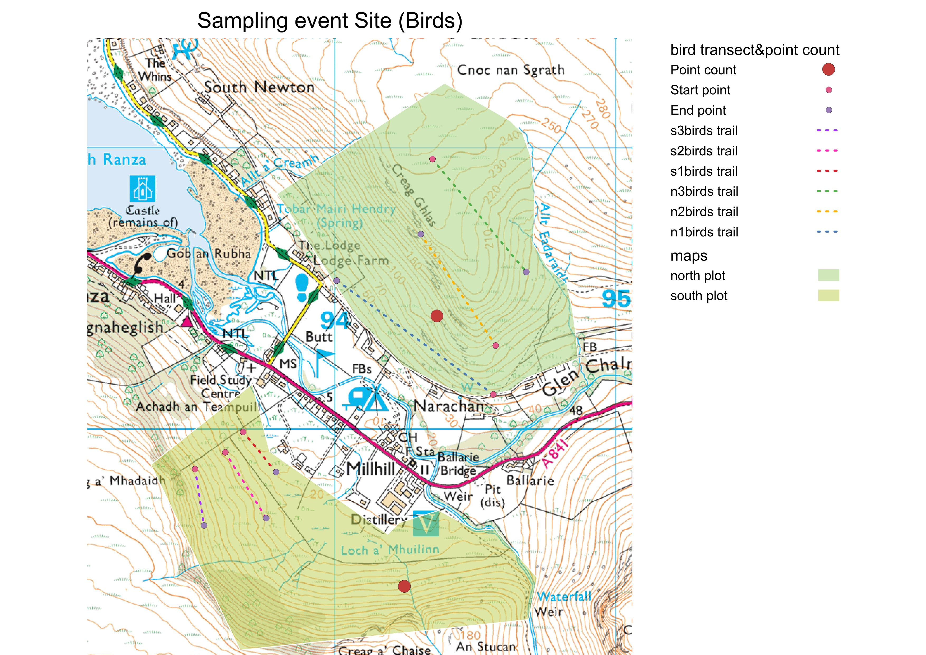

*Fig 2. Sampling event site of trees*

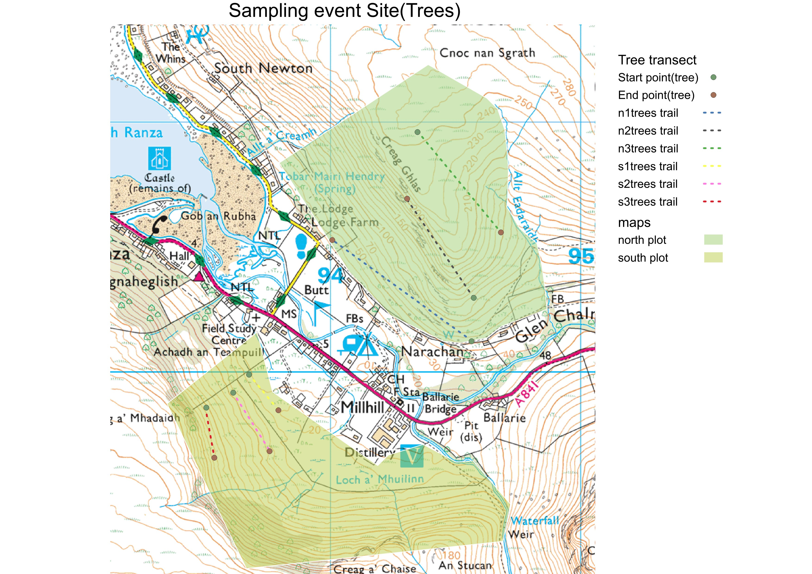

The taxa focus was determined based on practical considerations. Birds were chosen due to their ease of identification to the species level, rapid species accumulation curves, and ease of identifying them by their calls. What’s more, there are high likelihood of encountering protected species, such as the golden eagle. There are also apex predators which play an important role in ecosystem regulation.

We sent out teams of two researchers, one to record data on the birds and the other to record data on the trees.

**2.2.3 Invertebrates Survey**

The chosen methods included pitfall trapping, sweep netting and kick sampling. Pitfall (Plastic cup with a little water and soap to break water surface tension (1cm)) traps were used to capture ground-level insects. In sweep netting, we sweep net through the air, vegetation, or over surfaces where the target organisms are likely to be present. As the net passes through the environment, it captures insects and other small invertebrates. Kick sampling involves disturbing the substrate by kicking or agitating the sediment in a specific area of the stream, to dislodge and sweep organisms downstream into a net or a container. Pitfalls offer a reliable and recognized method for capturing ground-dwelling invertebrates. Sweep netting provides a quick and comprehensive snapshot of diverse habitats, capturing flying and mobile invertebrates. Kick sampling is instrumental in efficiently sampling benthic invertebrates in freshwater and marsh environments. They are all tried and tested methods.

**2.2.3.1 Terrestrial Invertebrates Survey**

We set up 7/8 pitfall traps on both the north and south sides along a low transect, spanning the bank. The aim was to cover up to the boundary of the designated zone on the map. Some areas like ravines, bracken, and marsh made paths inaccessible all the way around. We got sufficient pitfalls considering small number of insects captured and high elevation. Pitfalls were collected the next day. Sweep netting was conducted between pitfalls at 2.5 minutes from each pitfall, with 16 sweeps. The lower transect was implemented on both sides, while the middle and top transects of south plot have done sweep netting. Locations of sweep netting and pitfalls could be found in figure 3.

*Fig 3. Sampling event site of terrestrial invertebrates*

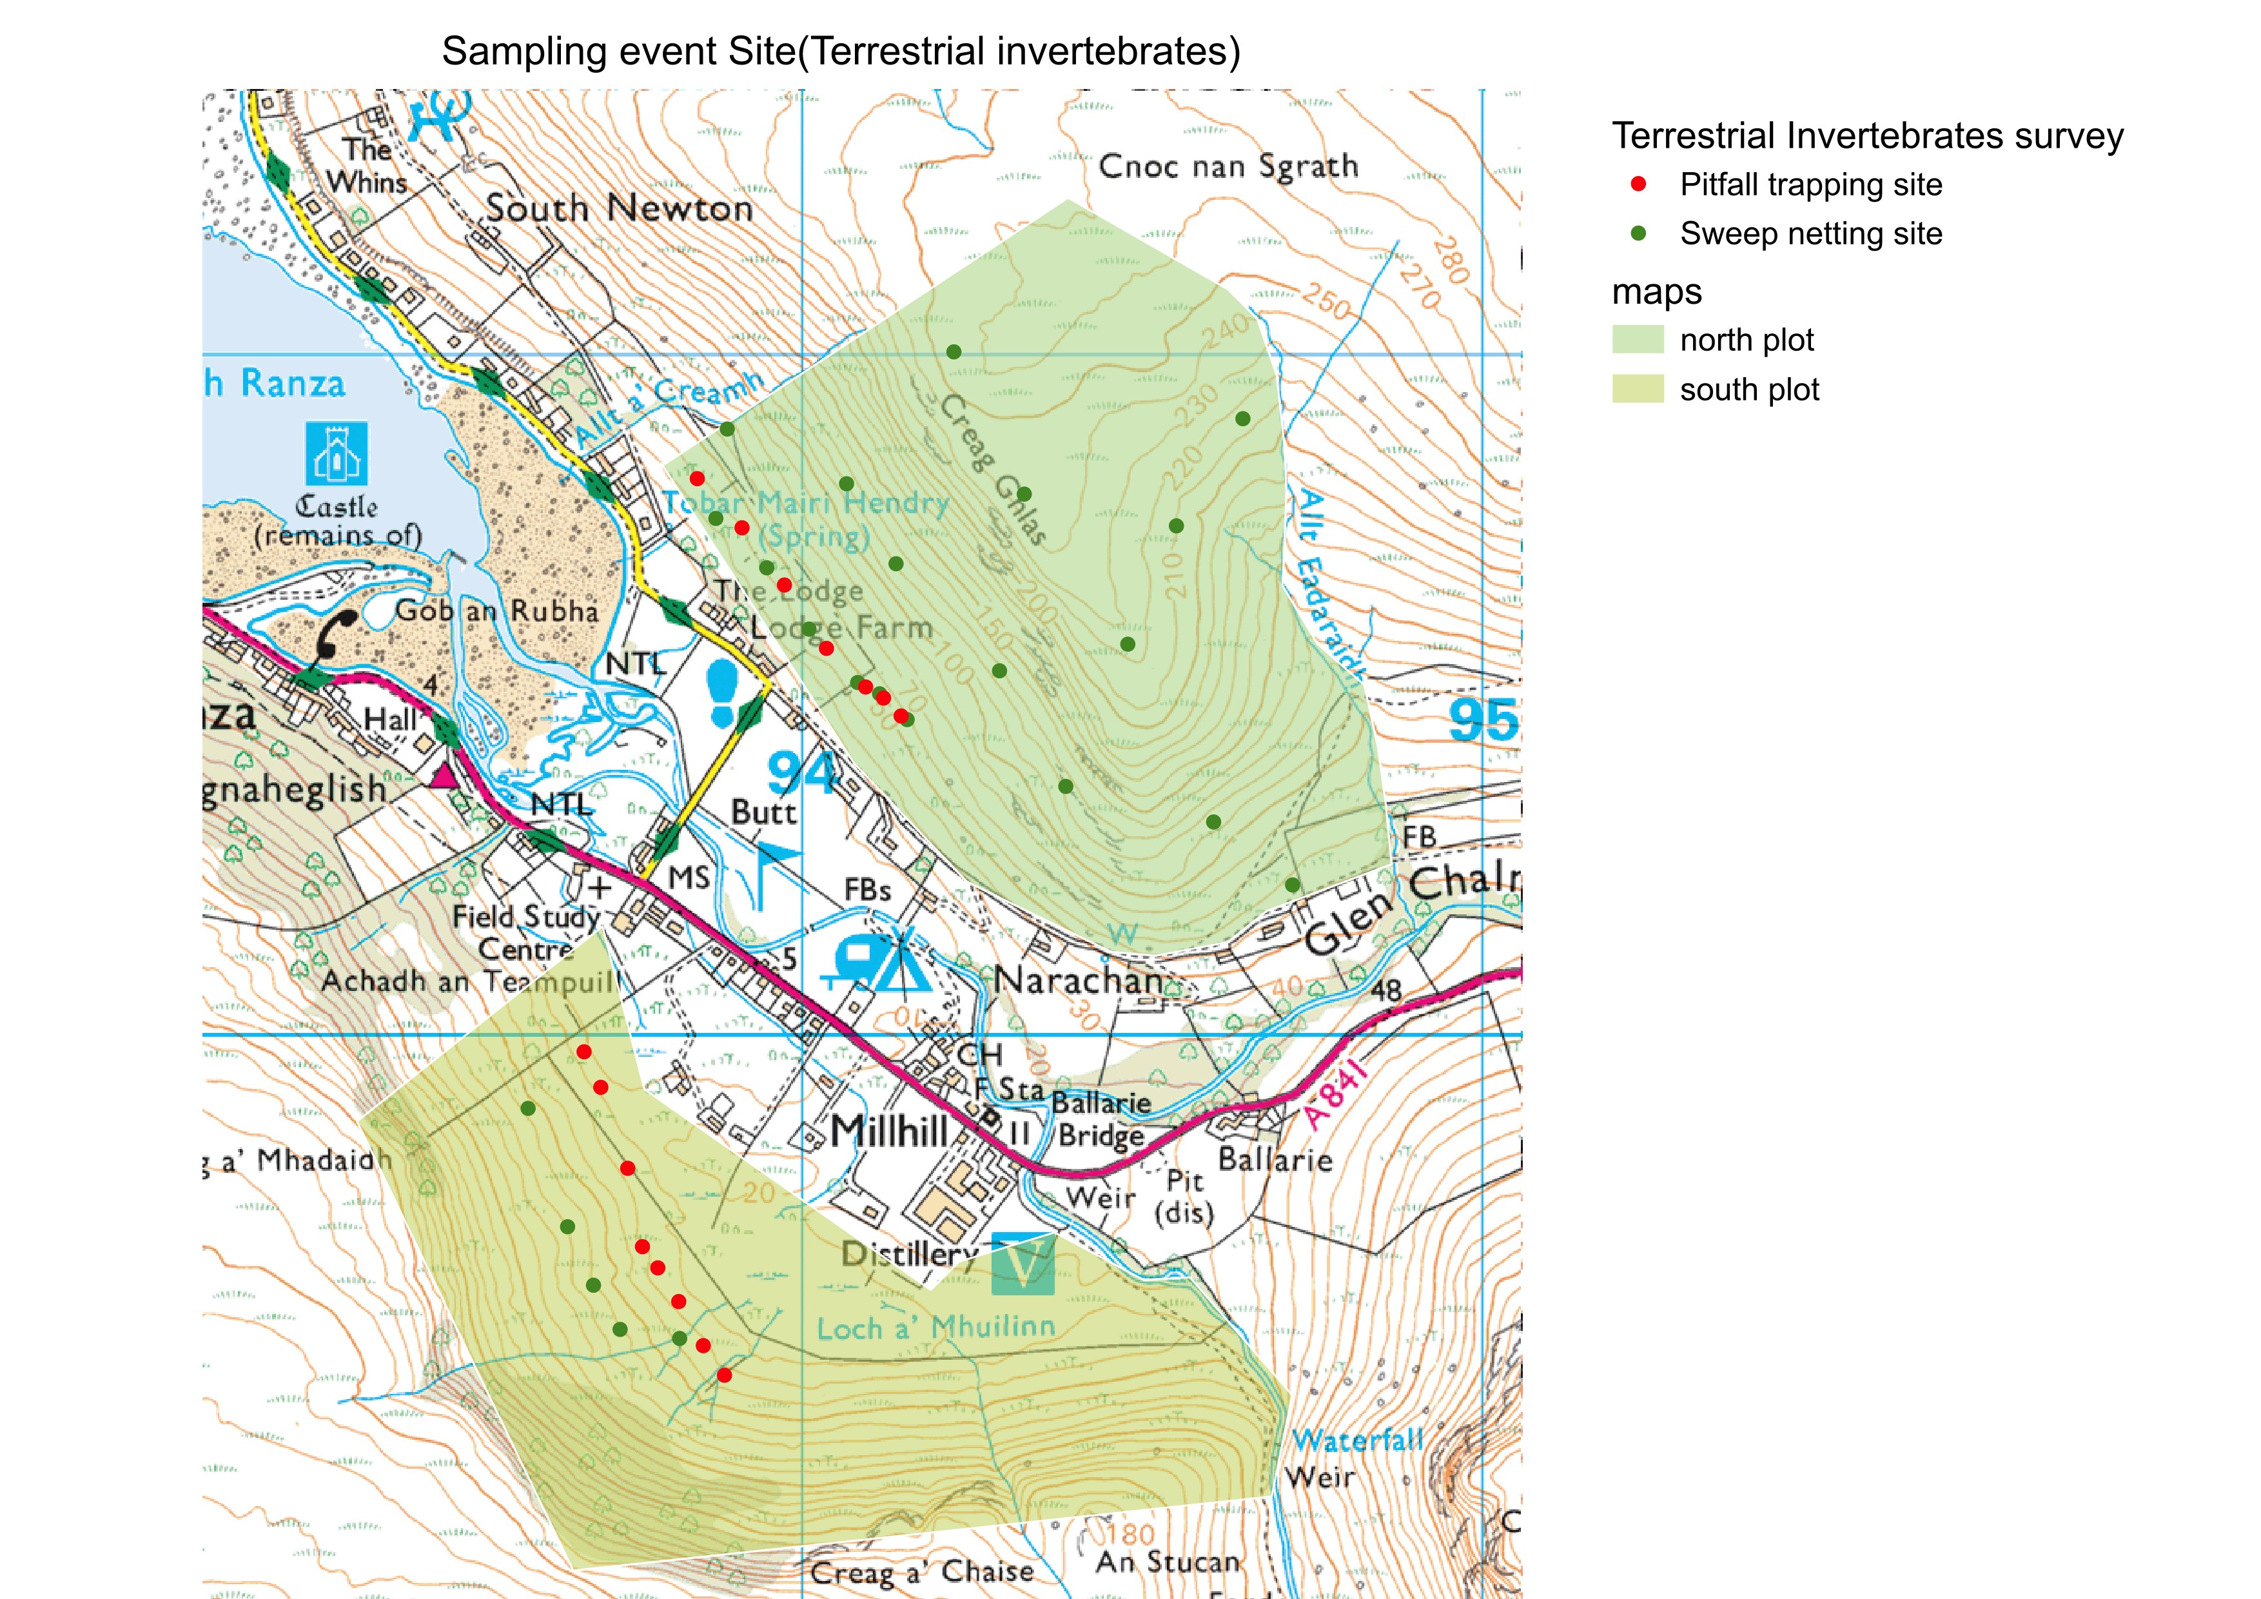

Insects were identified to family level. Some of them can be identified to species level. Most identifications were done in the field, but some insects were brought back for further examination, especially those difficult to identify to family level. Ticks were excluded from the count, and organisms smaller than 3mm were not considered.

Taxa which are easy to sample, and are useful for diversity calculations as a measure of conservation value were chosen. Decisions were made due to their ease of sampling, localized movement, and their role as a proxy for other species, such as birds and bats, in trophic level diversity calculations.

**2.2.3.2 Aquatic Invertebrates Survey**

We designed to assess aquatic invertebrate diversity by using kick sampling in three different areas: southern streams, marshes, and northern streams. Five sites were strategically selected along the southern streams and spaced approximately 50 meters apart. In marsh, we choose 5 different sites in south, do the survey opportunistically where possible due to size of stream. And in North plot, five samples were taken at approximately 20 meters intervals along northern streams for a total distance of 100 meters. Two researchers sampled by moving upstream, with a duration of 2 minutes in the southern stream and 3 minutes in the northern stream. Additionally, in the southern stream, six rocks were rubbed at each point to capture invertebrates. The same kick sampling protocol was applied to the marsh, but with a shortened duration of 30 seconds due to silt conditions. We took five samples on both the east and west sides of the marsh. Locations of kick-sampling could be found in figure 4.

*Fig 4. Sampling event site of aquatic invertebrates*

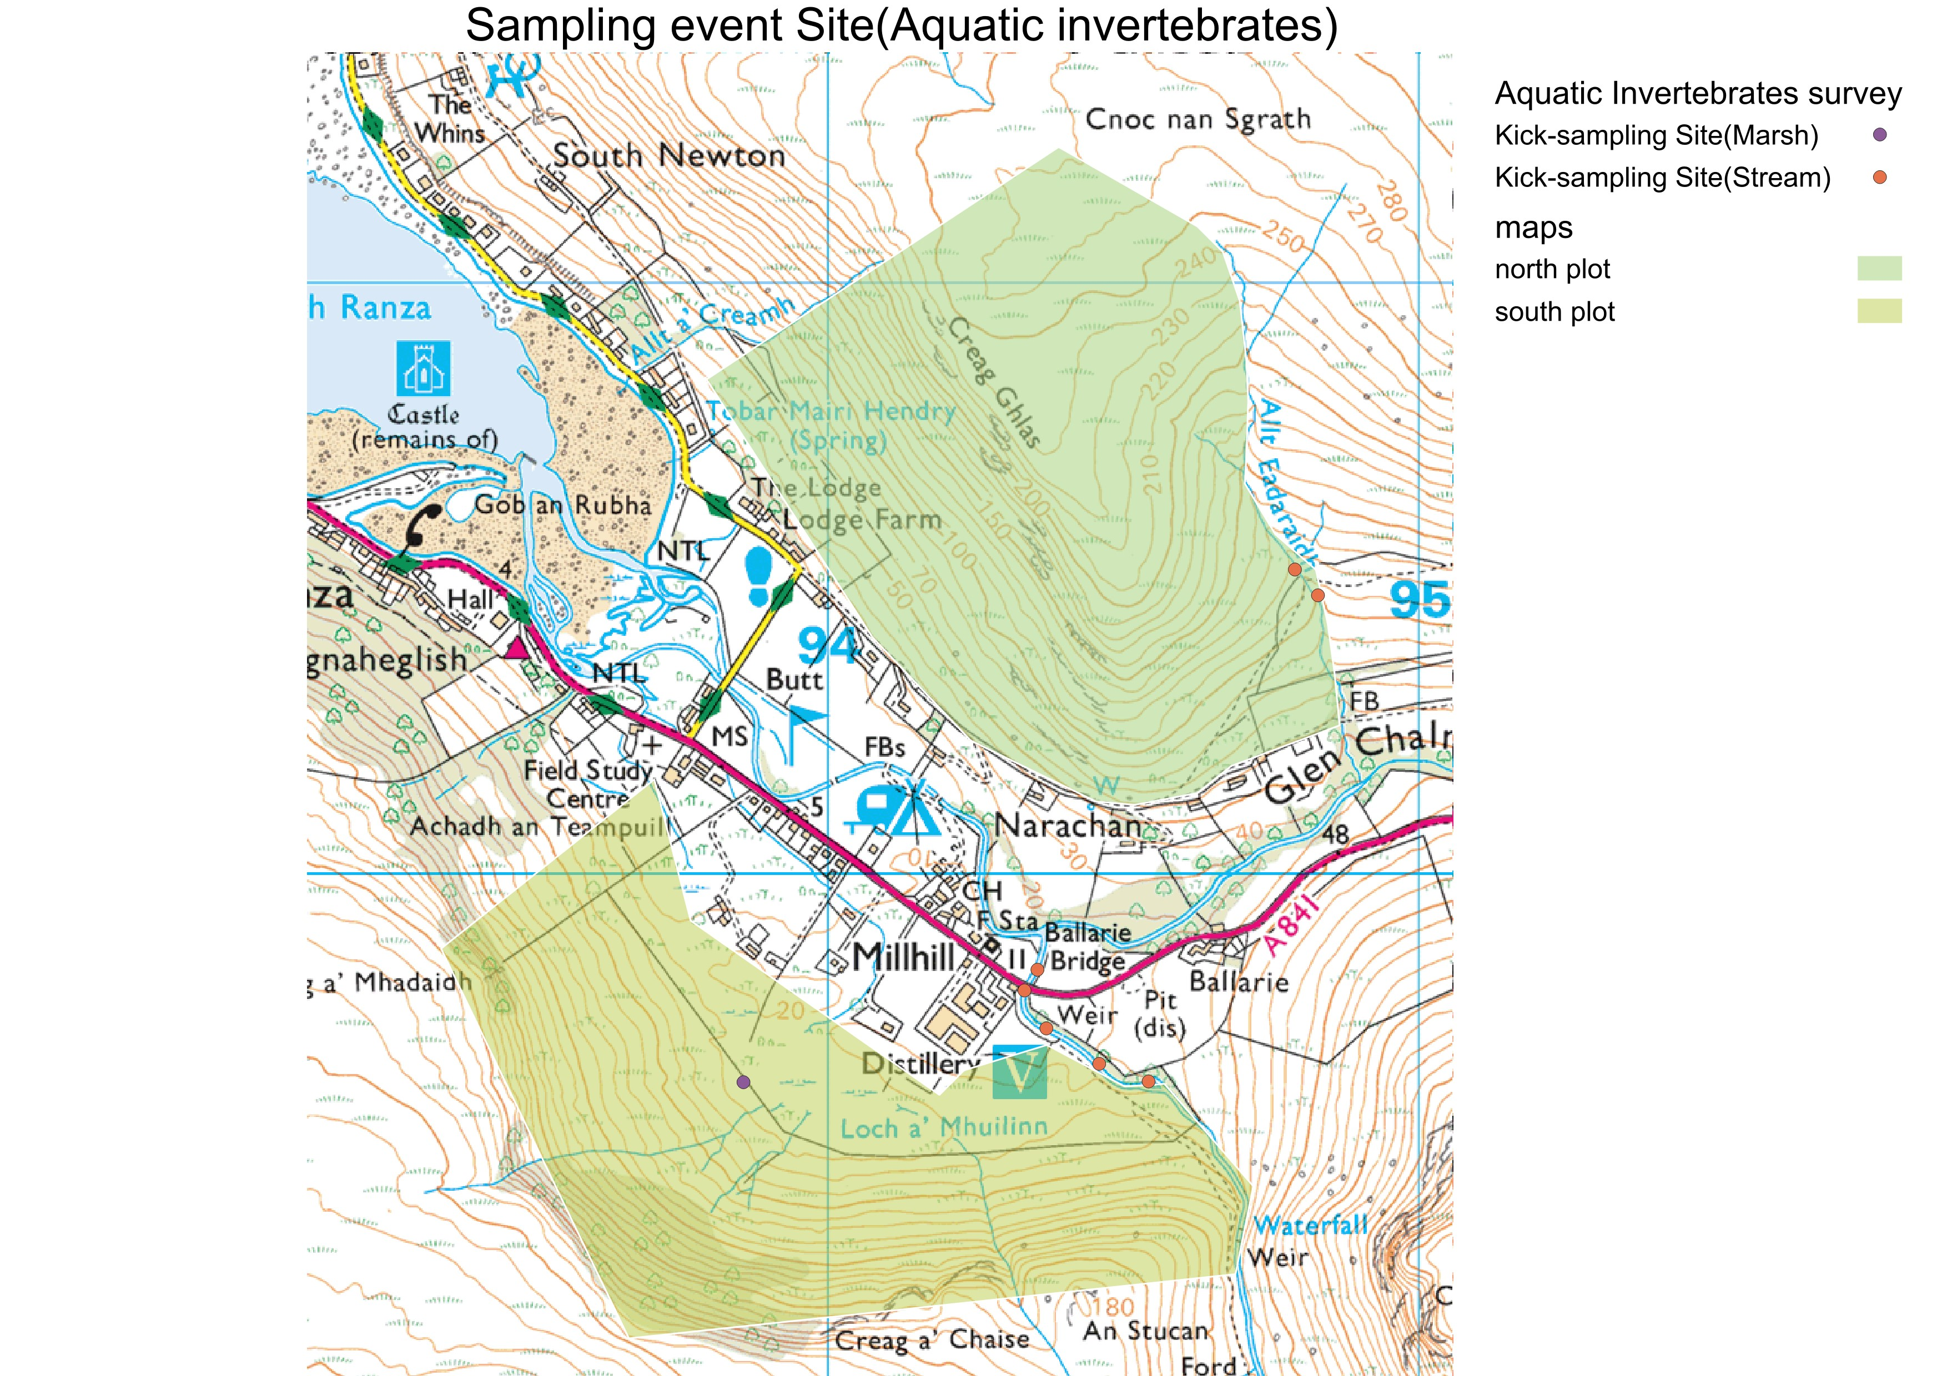

We selected species that are easy to identify and useful for diversity calculations, some species can live both in freshwater and on land, some can be indicators of water quality Both of them can help us in our surveys.

**2.2.4 Mammals Survey**

We used camera traps and audio moths to do mammals survey. We can capture images of big mammals, get a discreet and remote assessment of their behaviours and presence in the study area by utilizing camera traps. In the meanwhile, we conducted bat survey through audio moths. These audio recorders were strategically deployed to capture echolocation calls of bats, enabling a non-intrusive and effective method for species identification. We recorded species that captured by incidental sighting at the same time.

Three distinct deer tracks were carefully selected on each plot, maintaining a distance of approximately 50-100 meters between traps to ensure comprehensive coverage. 6 camera traps were left in one track for 24 hour, so there is 18 sites in total. Special attention was given to placement, favouring areas with limited vegetation and away from branches. The camera traps operated on a motion-triggered mechanism with a 1-minute delay. The audio moth devices were deployed over three nights. On the first night, setups were only in south wooded habitats. On the second night cameras were placed in the marsh (south) in first night and second night, the third night and forth night near the stream (north). We have considered surrounding vegetation and potential roosting sites. Recording started from 7:00 PM to 7:30 AM, which is half an hour before sunset and after sunrise to capture early and late bat activity. The cameras and audio moths placing position can be found in Figure 5 and Figure 6.

*Fig 5. Camera trap site*

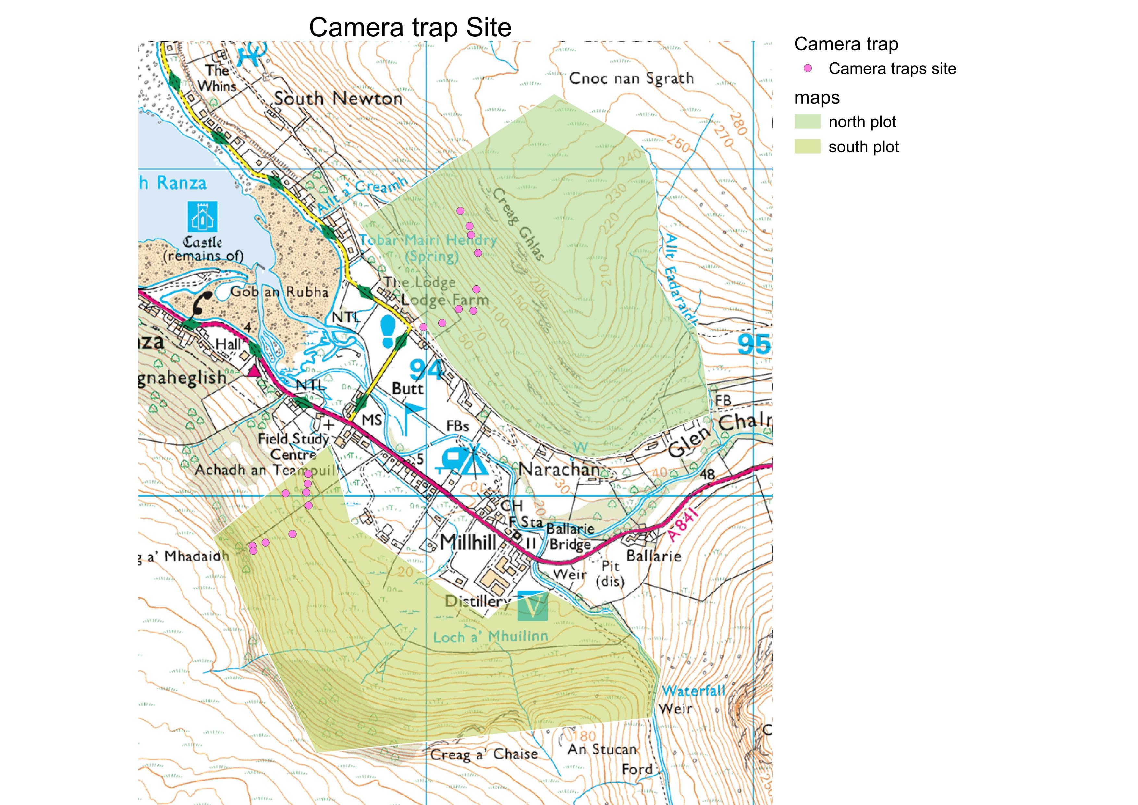

*Fig 6. Audio moth site*

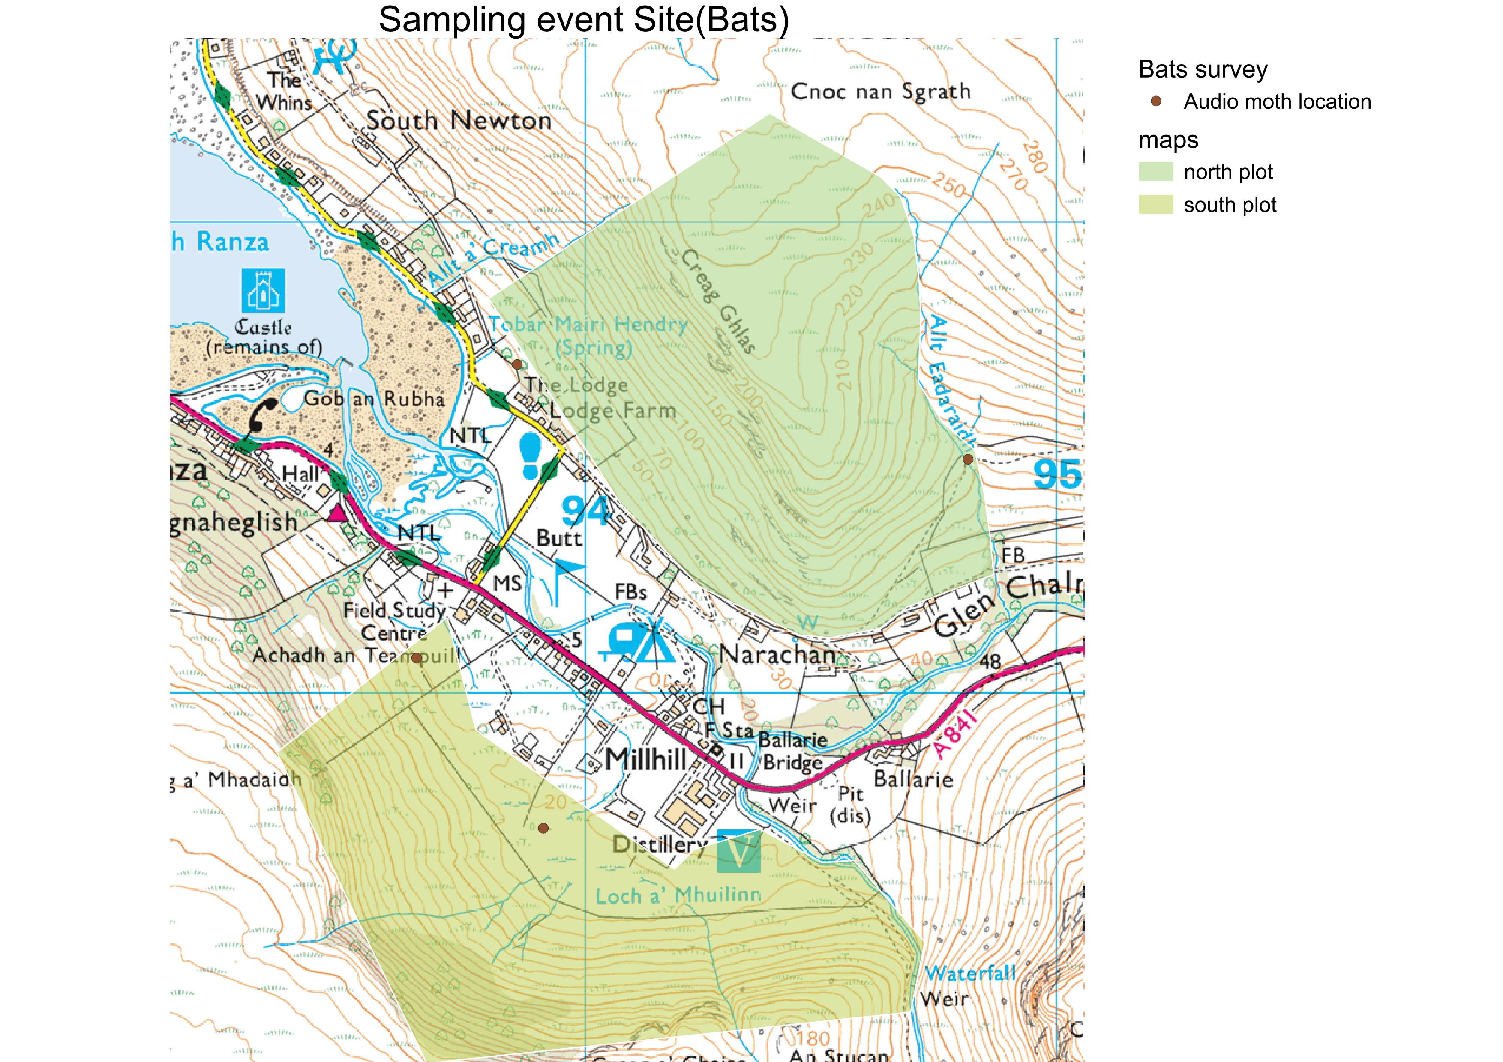

Larger mammals with their extensive home ranges, bring challenge to species survey. We need to focus on species crucial to ecosystem services, which contributes to tourism and farming. Such as the renowned "Flagship" species. Additionally, the inclusion of protected mammals like badgers, red squirrels, and bats was imperative. For some overpopulated species like red deers, it's also necessary to know their numbers. Big mammals can be easily captured in cameras. However, bats required specialized audio equipment for effective monitoring, and the use of small mammal traps was subject to permission. If protected small mammals were identified in the desk survey, it could potentially warrant future investigations in a Phase II study.

**2.2.5 Team organization**

When we were organizing team to conduct the survey and dividing up roles, we need to decide first what needs to be team work and what can be done independently. The decision-making process was structured by considering individual contributions and proper role. We divided tasks based on taxa, allocate tasks to team members according to members’ knowledge, expertise, and previous experiences in studying or identifying specific taxa. Additionally, we considered members' interests in studying certain taxa, assign them to the same group to facilitate learning from expert members. To enhance the team's skills and diversify experiences, we implemented a rotation system, allowing individuals to sample different taxa. Notably, some team members stayed in same taxa group to make sure our method be consistent. Method rotation was somewhat limited due to the availability of personnel for specific tasks, such as audio moths and camera traps. Safety considerations also influenced our organization, requiring team members to work in pairs or small groups in dangerous areas.

Information on the member allocation of the survey method can be found in table 2.

*Table 2. Method allocation*

|  |  |  |
| --- | --- | --- |
| **Day 1** | | |
| **Method** | **North plot** | **South plot** |
| **Transect(Birds and Trees)** | 2 people | 2 people |
| **Sweep netting and pitfall trapping** | 2 people | 2 people |
| **Audio moth** | 2 people | |
| **Camera trap** | 1 person | |
| **Day 2** | | |
| **Method** | **North plot** | **South plot** |
| **Point counts** | 2 people | 2 people |
| **Kick sampling** | 2 people | 2 people |
| **Audio moth** | 2 people | |
| **Camera trap** | 1 person | |

**2.3 Assessment**

The assessment methodology employed in this report adheres to the Guidelines for Ecological Impact Assessment, as outlined by the Institute of Ecology and Environmental Management (IEEM) in 2018. These guidelines serve several key purposes: to foster good practice, advocate for a scientifically rigorous and transparent approach to Ecological Impact Assessment (EcIA), establish a common framework for EcIA to facilitate improved communication and collaboration among ecologists involved in such assessments, and furnish decision-makers with pertinent information regarding the anticipated ecological effects of a project.

The Guidelines provide comprehensive guidance across key facets of EcIA, including

• Establishing the baseline

• Important ecological resources and features

• Impact assessments

• Avoidance, Mitigation, Compensation and Enhancement

**2.3.1 Establishing the baseline**

The establishment of ecological baseline conditions is vital in gauging the potential impacts of proposed activities. The baseline represents the ecological state in the absence of the intended project, serving as a benchmark against which alterations can be measured. It is imperative to fully consider the factors defining this baseline, recognizing that conditions may evolve between the assessment phase and project implementation. Assessing the impacts necessitates a comprehensive understanding of baseline conditions both preceding and concurrent with project activities.

Examples of factors that should be used to identify potential changes in baseline conditions include:

• trends in species population and distribution

• rates of potential colonisation by new species and habitats

• ecological processes, such as succession

• physical processes – e.g. currents, disruption of sediment pathways

• likely changes in agricultural practice, including agri-environment schemes

• expected outcomes from current and predicted management practices

• trends in habitat quality e.g. resulting from pollution or pollution control

• environmental trends e.g. climate change

• management plans and conservation objectives for designated sites

• the effects of other projects

**2.3.2 Finding Important ecological resources and features**

To decide which ecological resources and features (habitats, species, ecosystem and their functions/ processes) are important, we need to do a detailed assessment.

The significance of ecological features can stem from various factors, and it is essential to elucidate the reasoning behind their selection to underscore a robust decision-making process. This significance may result from various aspects, including the quality or expansiveness of designated sites or habitats, the rarity of certain habitats or species, the level of threat they face across their range, or the pace at which they are experiencing decline. Providing a clear rationale for the selection process ensures transparency and strengthens the comprehensiveness of the ecological feature identification.

In this report, all ecological resources or features are assigned to a value relating to their

geographic frame of reference, using the following frame.

• International and European

• UK

• National(Scotland)

• Regional (Western Scotland)

• County(North Ayrshire)

• District(Isle of Arran)

• Site(Lochranza)

• Negligible

**2.3.3 Conducting impact assessments**

The impact assessment process involves:

• identifying and characterising impacts and their effects

• incorporating measures to avoid and mitigate negative impacts and effects

• assessing the significance of any residual effects after mitigation

• identifying appropriate compensation measures to offset significant residual effects

• identifying opportunities for ecological enhancement.

**2.3.4 Providing methods for Mitigation**

Avoidance, mitigation, compensation and enhancement measures should be identified as part of the EcIA process. The formulation of mitigation measures is an iterative process, considering realistic achievability and the anticipated level of success, guided by best practice recommendations and evidence.

**2.3.4.1 Avoidance and mitigation**

Avoiding and mitigating negative impacts is most effectively accomplished by evaluating the potential impacts of a project during the initial stages of project design and throughout its development. Consideration of alternatives also works.

**2.3.4.2 Compensation**

Compensation should be specifically focused on same ecological features affected. Replacement areas must be likely to the lost or damaged ecological features, or possessing similar features and functions or having the potential, with suitable management, to replicate the original ecological conditions. It is crucial that compensation can gain approximately the same effect as the lost area, benefiting the same habitats and species impacted by the project.

**2.3.4.3 Enhancement**

Enhancement involves improving ecological features or introducing new features, leading to raising biodiversity. It is not likely to compensate negative impacts; instead, it goes beyond compensation.

**3.Results**

Data used in this report can be found at this github link below:

<https://github.com/momo20011109/Arran-Survey>

**3.1 Desk Study**

Through investigations on NatureScot, Wikipedia, Scotland's Environment, and the UK National Biodiversity Network, no internationally protected areas such as Special Areas of Conservation (SACs) or National Nature Reserves (NNRs) were found within a 5 km radius of the survey area. Searches on the NBN Atlas revealed the presence of some invasive, protected, and priority species.

NBN Atlas shows that in south plot there are four invasive species, including Eurasian sparrowhawk (*Accipiter nisus*), grey heron (*Ardea cinerea*), hooded crow (*Corvus cornix*), and grey wagtail (*Motacilla cinerea*). There were twelve priority species, such as European eel (*Anguilla anguilla*) and small pearl-bordered fritillary (*Boloria selene*), along with forty protected species, including Kinnikinnick (*Arctostaphylos uva-ursi*) and common buzzard (*Buteo buteo*), all of them were selected from the following lists: Invasive Species, RSPB Priority Species, Birds Directive Annex 1, Annex 2.1, and Annex 2.2 - combined, EC CITES - Annexes A, B, C, and D combined, Bern Convention - Appendix 1, Appendix 2, and Appendix 3 combined, the Scottish Biodiversity List and Red List GB post 2001.

The north plot has nine invasive species, including Sycamore (*Acer pseudoplatanus*) and Entire-leaved cotoneaster (*Cotoneaster integrifolius*), two priority species: (*Hyacinthoides non-scripta*) and (S*ciurus vulgaris)*, and many protected species, such as common sandpiper (*Actitis hypoleucos*), common cuckoo (*Cuculus canorus*), and western house martin (*Delichon urbicum*), similarly selected from the same lists. Searching results can be found in Appendix 1.

**3.2 Phase I habitat survey**

**3.2.1 Habitat**

In the South plot, the land cover comprises expansive areas of woodland and heather moorland, interspersed with limited regions of bracken, blanket bog, and scrub. In the North plot, extensive coverage is observed for bracken and heather moorland, with smaller areas occupied by raised bog and scrub. Notably, the habitat survey identified the invasive species Rhododendron within this plot.

Result of survey can be seen in Fig 7 and Fig 8.

*Fig 7. Phase I habitat survey of north plot*

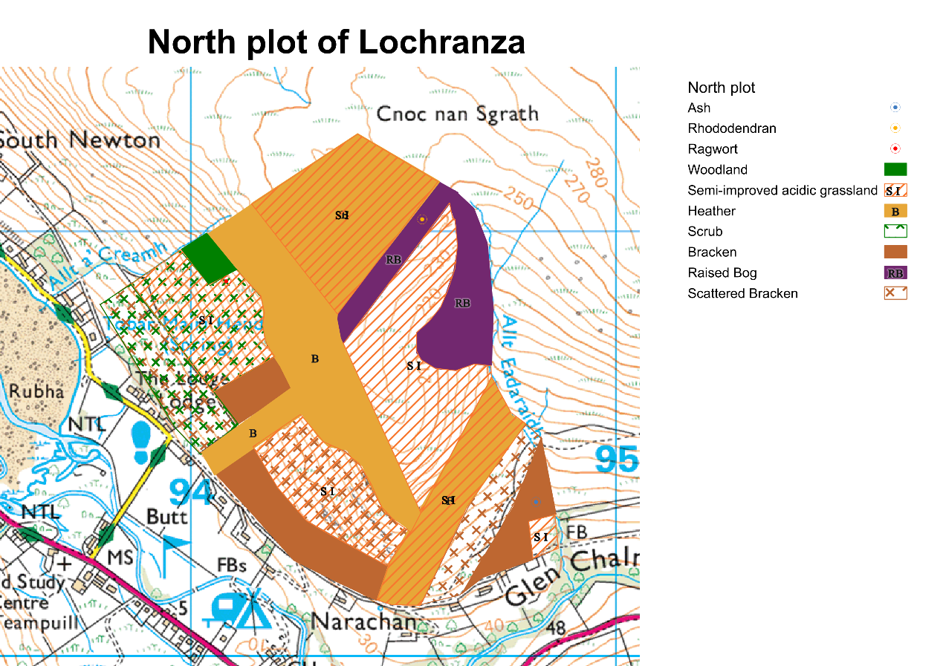

*Fig 8. Phase I habitat survey of south plot*

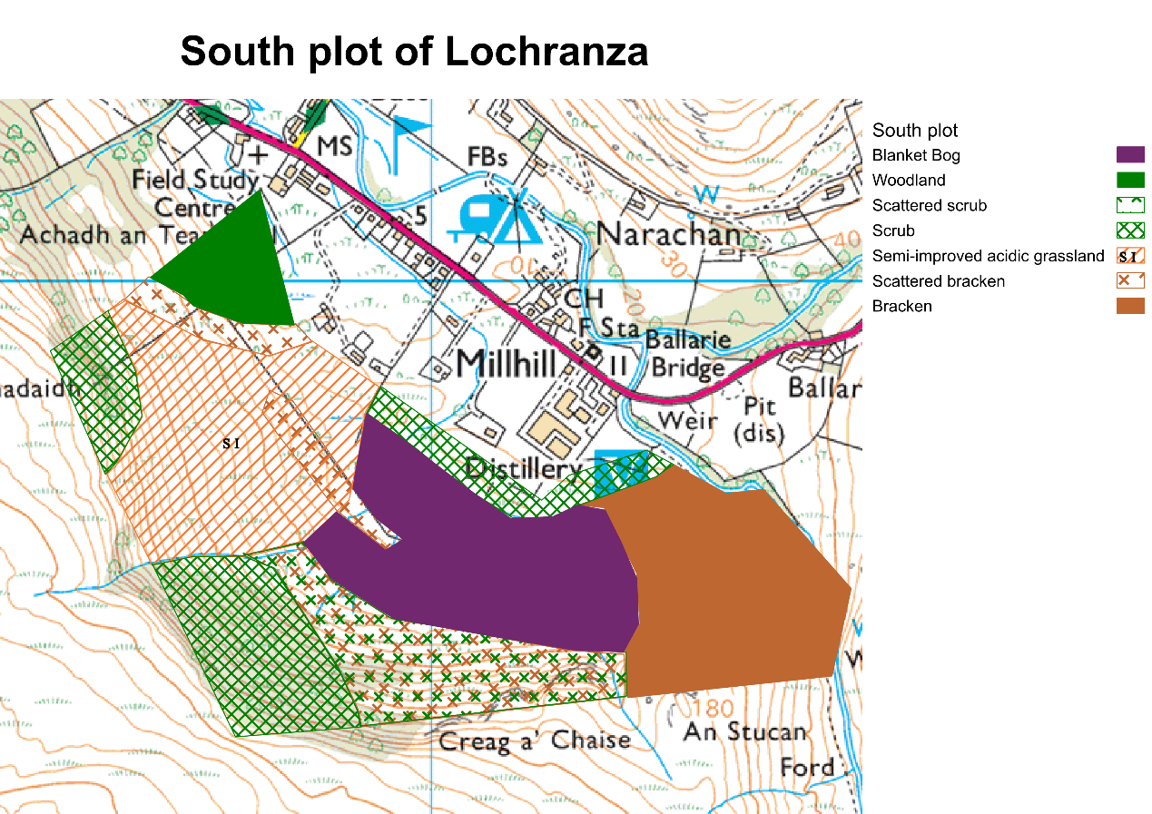

**3.2.1.1 Woodland**

The area of woodland is on the northwest and south faces of the South plot. In the North plot, few trees are present on the north side.

**3.2.1.2 Heather Moorland**

North plot feature extensive areas of heather moorland habitat. The heather moorland on the western side grows together with grass. In the South plot, this habitat doesn’t exist.

**3.2.1.3 Bog**

In the North plot, the bog habitat is situated to the northeast at a higher elevation and is categorized as raised bog. One invasive species rhododendron located there. In the South plot, the bog habitat located in the central area at a lower elevation and is categorized as blanket bog.

**3.2.1.4 Scrub**

In the North plot, scattered scrub is found in the western area, there is one native species ragwort. In the South plot, dense scrub spreads around.

**3.2.1.5 Bracken**

In the North plot, the southern area is bracken habitat, the southeast area is the densest. In the South plot, there is a big part of bracken in the west.

**3.2.2 Plants**

In the south plot, we identified five tree species, namely Hawthorn (*Crataegus monogyna*), Gorse (*Ulex europaeus*), Silver Birch (*Betula pendula*), Holly (*Ilex aquifolium*), and Ash (*Fraxinus excelsior*). In the north plot, we identified Grey Willow (*Salix cinerea*), Rowan (*Sorbus aucuparia*), Hawthorn, Ash and Rhododendron (*Rhododendron ponticum*) in low transect. Rhododendron is an invasive species. Bracken in east is too dense and was not traversable, so we can not identify trees there. Data for middle and upper transects were lost.

**3.3 Baseline Ecological Surveys**

Richiness of each taxon can be found in Table 3. The α biodiversity of each taxon can be found in Table 4.

*Table 3. Richness of Taxon*

|  |  |  |
| --- | --- | --- |
|  | **South** | **North** |
| **Trees(species)** | 5 | 3 |
| **Birds(species)** | 14 | 15 |
| **Terrestrial invertebrates (family)** | 30 | 38 |
| **Aquatic invertebrates (order)** | 9 | 6 |
| **Bats(species)** | 14 | 13 |
| **Other species** | 3 | 5 |
| **Invasive species** | 0 | 1 |
| **Priority species** | 0 | 0 |
| **Protected species** | 5 | 3 |

*Table 4. α biodiversity of Taxon*

|  |  |  |
| --- | --- | --- |
|  | **South** | **North** |
| **Trees** | 5 | 3 |
| **Birds** | 14 | 15 |
| **Terrestrial invertebrates** | 30 | 38 |
| **Aquatic invertebrates** | 9 | 6 |
| **Bats** | 14 | 13 |
| **Other species** | 3 | 5 |

**3.3.1 Birds**

Bird survey data reveals that in the south plot, Eurasian wren (*Troglodytes troglodytes*), Dunnock (*Prunella modularis*), Great tit (*Parus major*), Coal tit, (*Periparus ater*), Meadow pipit (*Anthus pratensis*), Chaffinch (*Fringilla coelebs*), Eurasian siskin (*Spinus spinus*), Eurasian blue tit (*Cyanistes caeruleus*), European robin (*Erithacus rubecula*) and Goldcrest (*Regulus regulus*) was recorded by using transects. Additionally, using point count surveys, Eurasian wren, European robin, Dunnock, and Western jackdaw (*Coloeus monedula*) were observed. Golden eagle (*Aquila chrysaetos*), Barn owl (*tyto alba*) and Carrion crow (*Corvus corone*) were discovered by incidental sightings. Among these, Dunnock, Great tit, Meadow pipit, and Eurasian wren are protected species.

In north plot, there were presence of Eurasian wren, Great tit, Garrion crow (*Corvus corone*), Dunnock, Meadow pipit, Raven (*Corvus corax*), Wheatear (*Oenanthe oenanthe*), Kestrel (*Falco tinnunculus*) and Hen harrier (*Circus cyaneus*). Additionally, using point count surveys, the presence of Hooded crow (*Corvus cornix*), Eurasian wren, Raven, Western jackdaw and Meadow pipit was recorded. Golden eagle, Peregrine falcon (*Falco peregrinus*) and Ring ouzel (*Turdus torquatus*) were discovered by incidental sightings Notably, Kestrel is a protected species. Though Dunnock is a protected species and Hooded crow is a invasive and protected species, they have not been recorded in list in north area.

According to the data, fourteen species were recorded in the north plot and fourteen species were also recorded in the south plot. there are 8 species in south plot that have not appeared in north plot. There are also 8 species in the north plot that have not appeared in south plot. The comparison of the quantities of bird species in the North and South is shown in Figure 9, species marked with a star sign are protected species. Quantities of bird species in each plot were shown in Figure 10.

*Fig 9. Quantities of bird species in North and South*

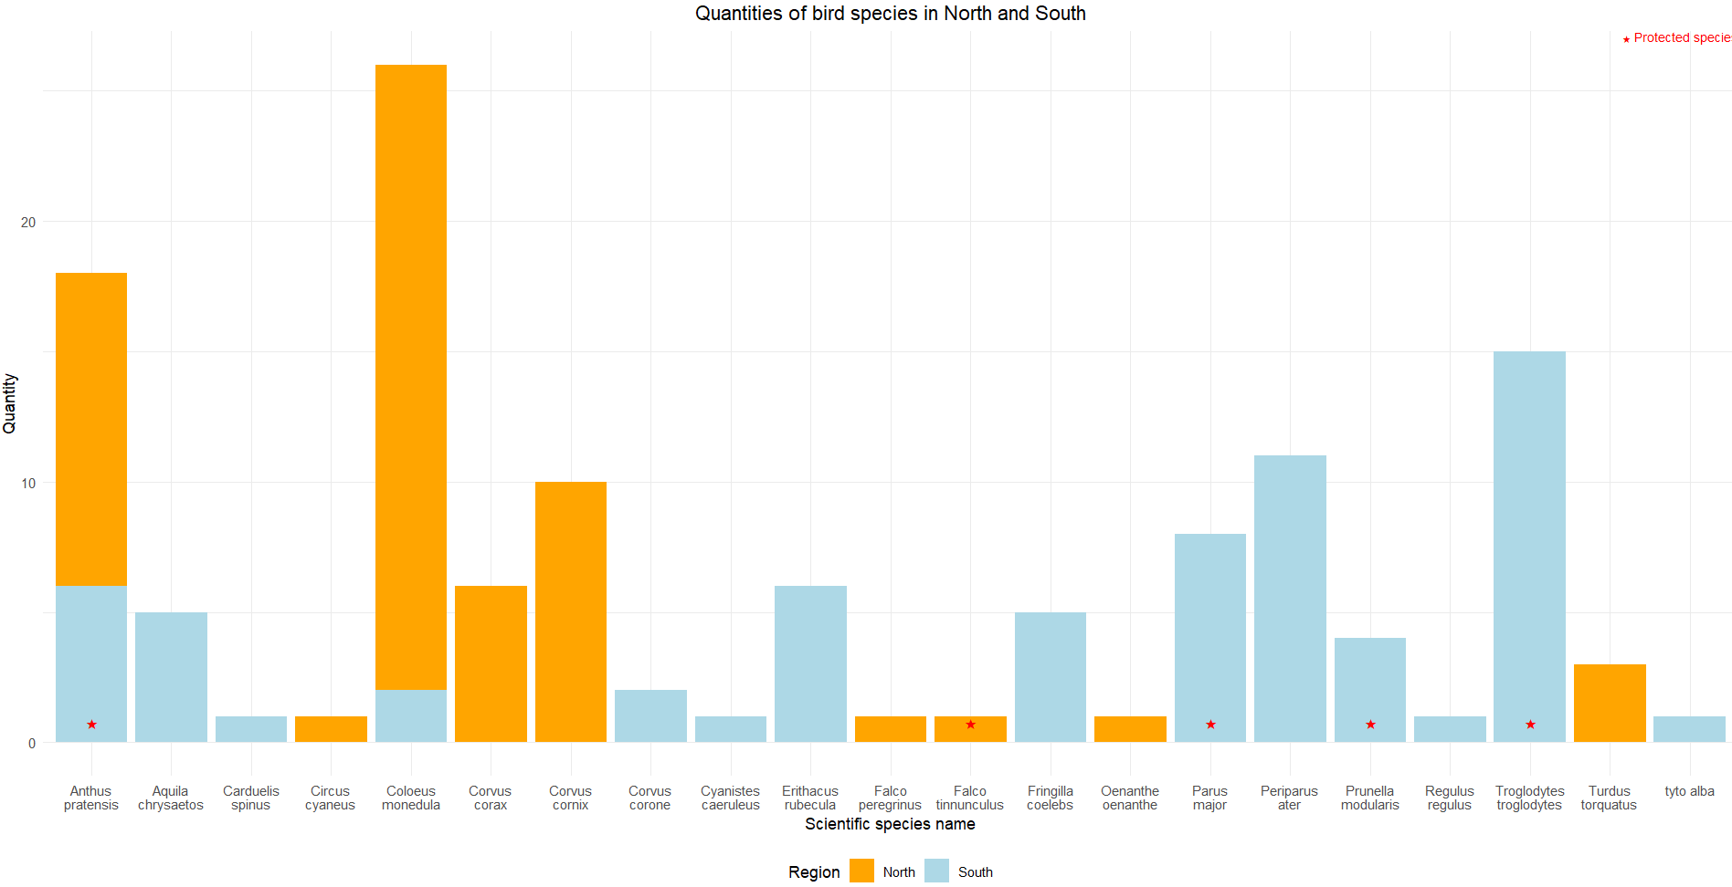

*Fig 10. Identified birds in each plot*

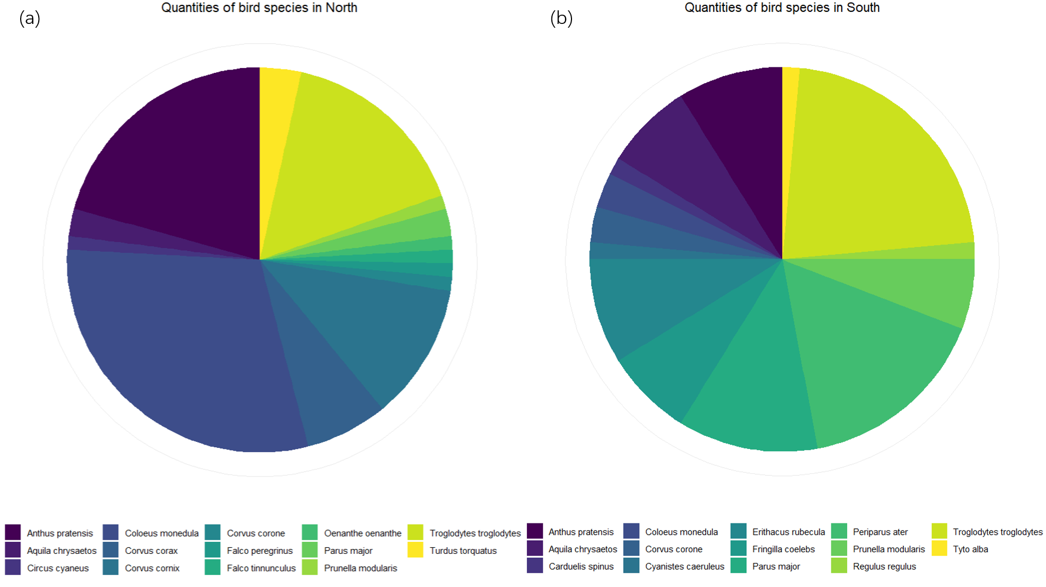

(a) quantities of birds species in south plot (b) quantities of birds species in north plot

**3.3.2 Terrestrial Invertebrates**

In north plot data, four invertebrates failed to be identified to family level and were therefore removed. In south plot data, fourteen invertebrates failed to be identified to family level and were therefore removed.

In this survey, invertebrates from the north came from 37 different families, and invertebrates from the south came from 29 different families. However, among these invertebrates, no protected/priority/invasive species were found from the list. The comparison of the quantities of invertebrate family in the North and South is shown in Figure 11. Quantities of invertebrate families in each plot were shown in Figure 12.

*Fig 11. Identified terrestrial invertebrates in North and South*

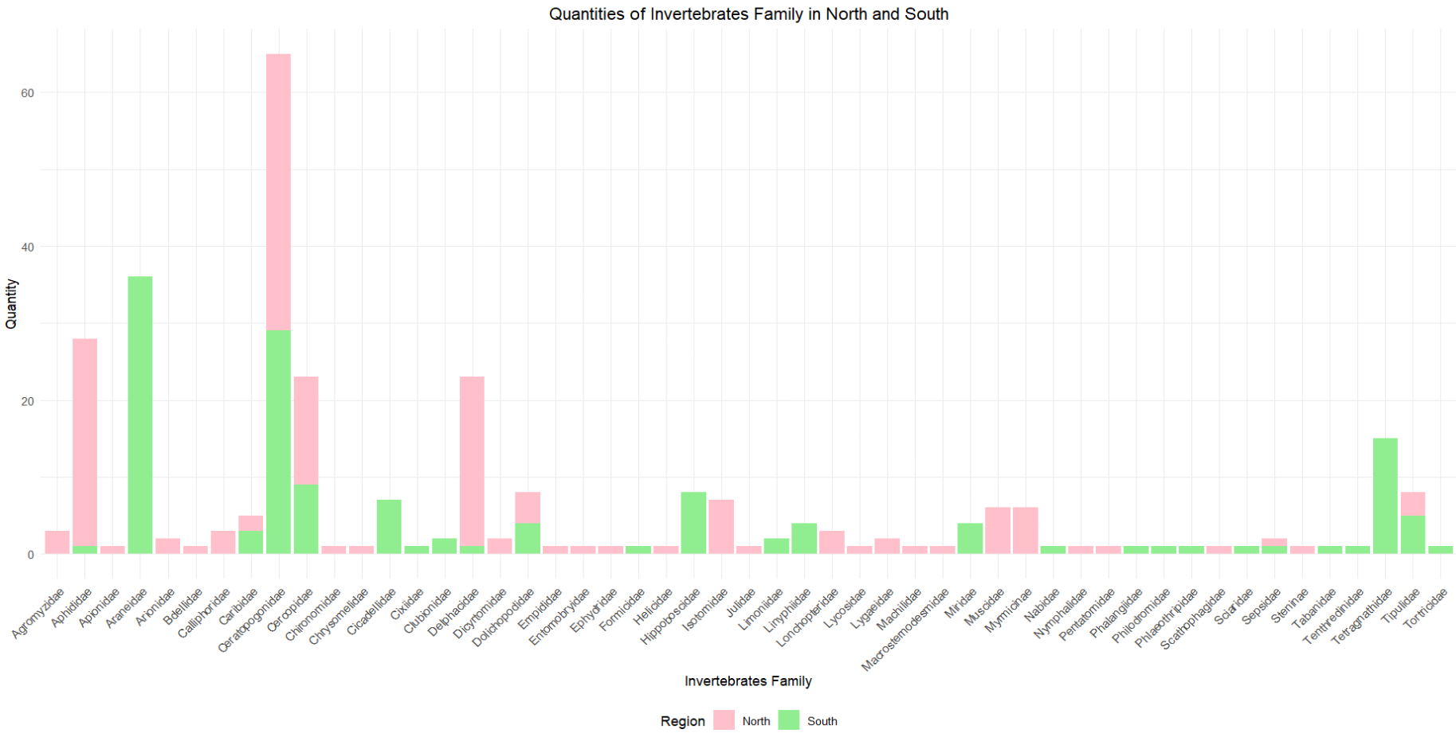

*Fig 12. Identified terrestrial invertebrates in each plot*

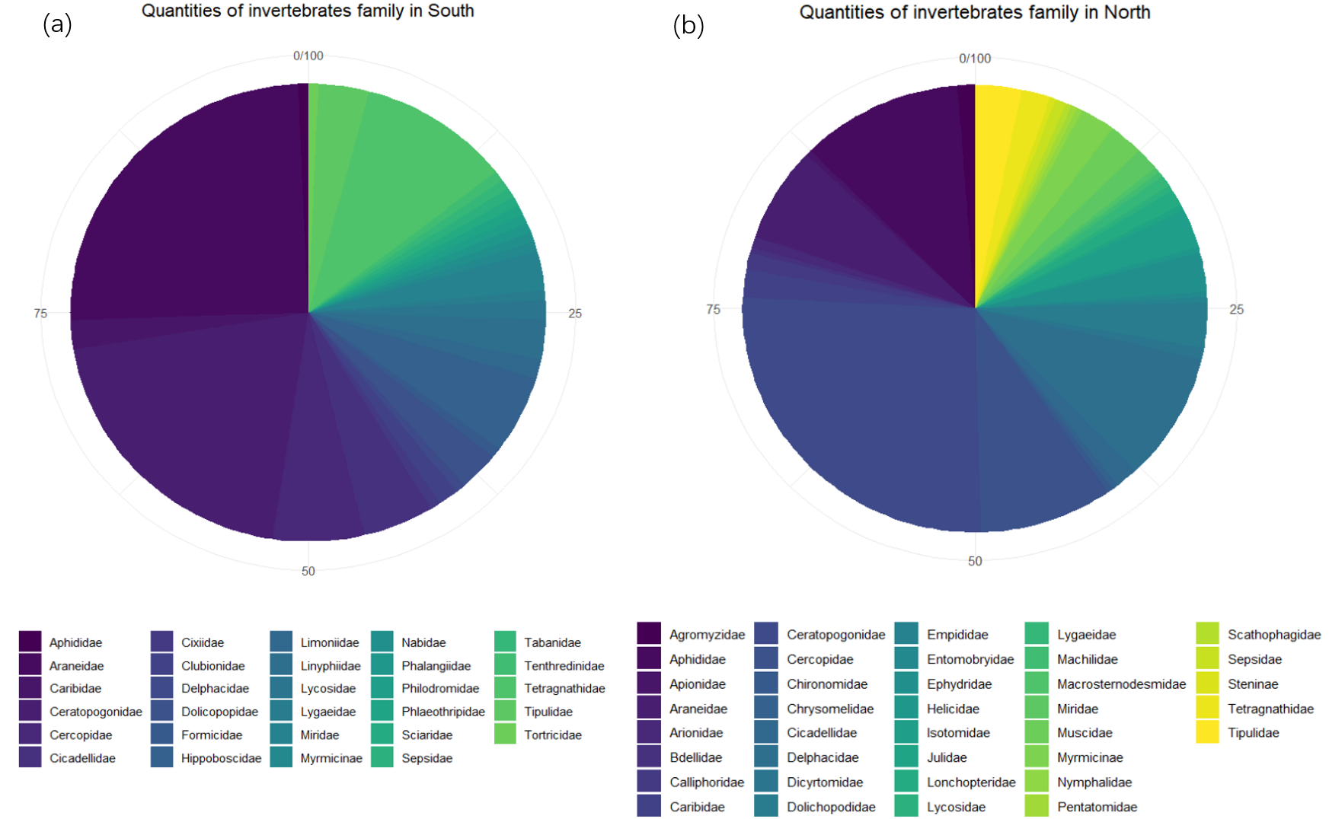

(a) quantities of invertebrate families in south plot (b) quantities of invertebrates families in north plot

**3.3.3 Aquatic Invertebrates**

In north plot data, seven species failed to be identified to family level. In south plot data, twenty-two insects failed to be identified to family level. the analysis was based on order level because of loss of data.

In this survey, invertebrates from the north came from 6 different orders, and invertebrates from the south came from 7 different orders. However, among these invertebrates, no protected/priority/invasive species were found from the list. The comparison of the quantities of invertebrate family in the North and South is shown in Figure 13. Quantities of invertebrate families in each plot were shown in Figure 14.

*Fig 13. Identified aquatic invertebrates in North and South*

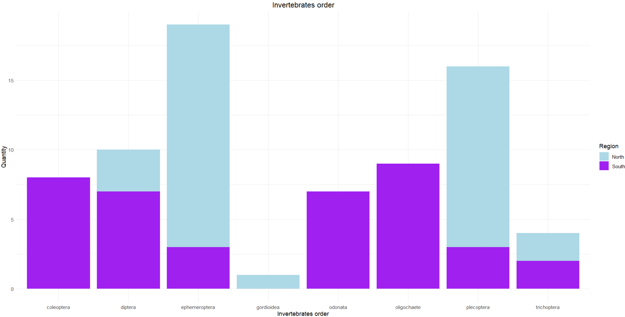

*Fig 14. Identified aquatic invertebrates in each plot*

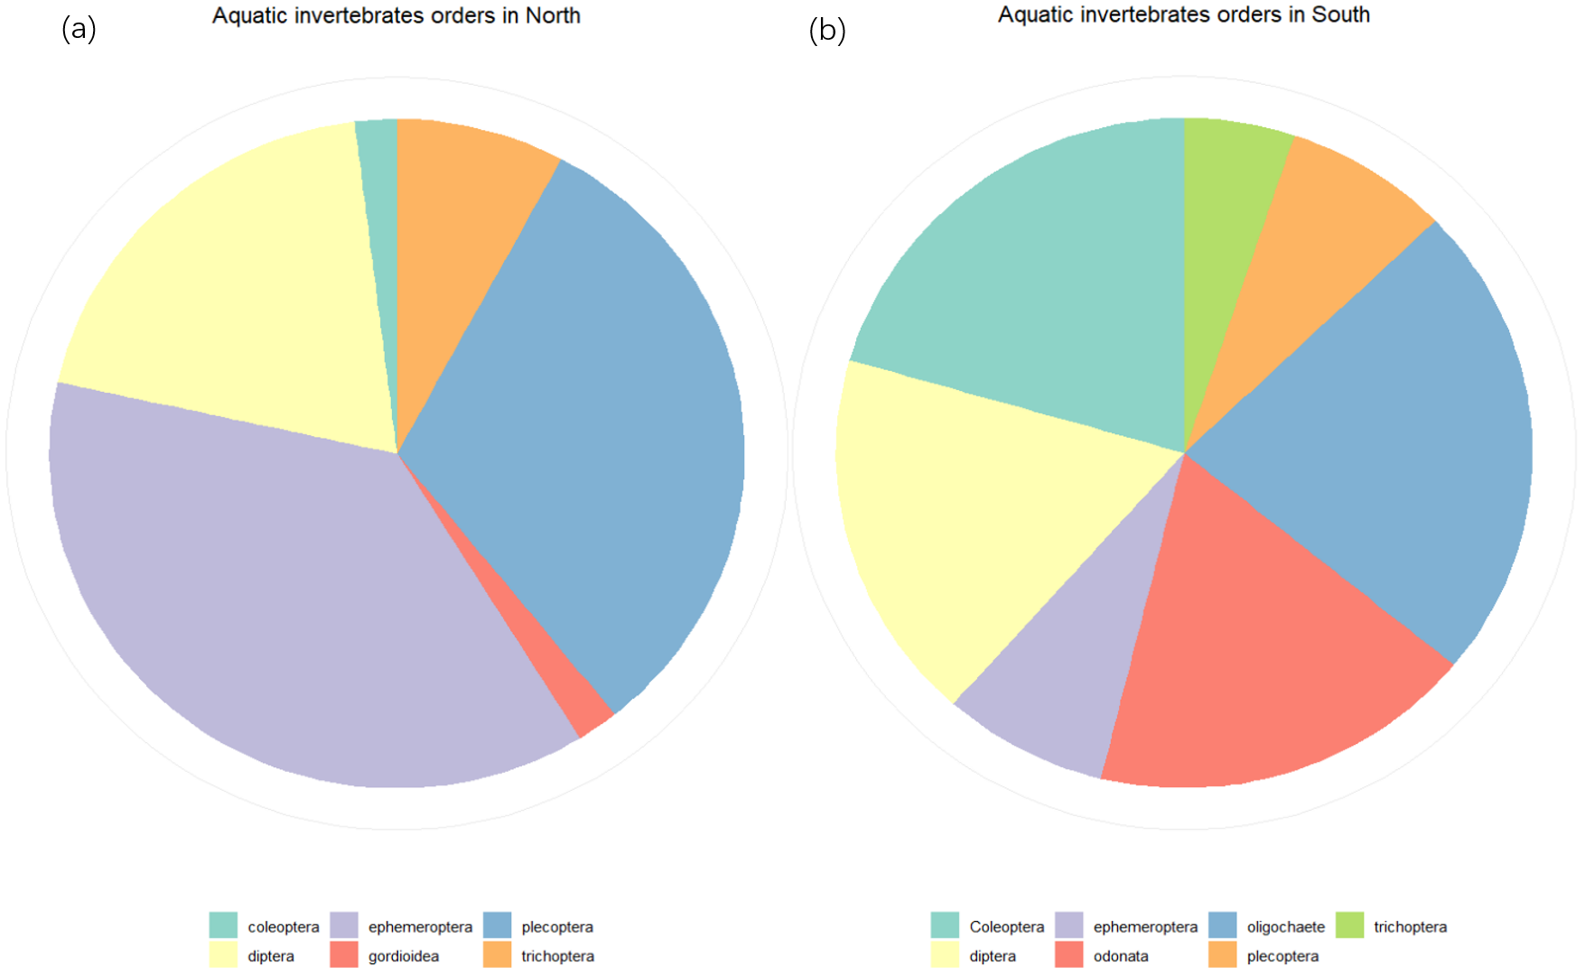

Because many species were identified only to ORDER level, the aquatic invertebrates data were used more for assessing local water quality, and we conducted water quality assessment by using BMWP/ASPT score.

The BMWP score system is based on families of benthic macroinvertebrates that have been given a score between 1 and 10 based on their pollution tolerance, with the most sensitive receiving the highest score. The scores for each family are added and an overall BMWP score is obtained, which gives an indication of the biological condition of the water body. Summary of water quality of stream and marsh can be found in Table 5.

*Table 5. Summary of water quality*

|  |  |  |  |
| --- | --- | --- | --- |
| **Location** | **BMWP score** | **ASPT score** | **Water quality** |
| **N1 Stream** | 15 | 3 | Moderate |
| **N2 Stream** | 0 | 0 | Unknown |
| **N3 Stream** | 5 | 1.25 | Very poor |
| **N4 Stream** | 15 | 2.14 | Poor |
| **N5 Stream** | 15 | 3 | Moderate |
| **S1 Stream** | 0 | 0 | Unknown |
| **S2 Stream** | 5 | 2.5 | Poor |
| **S3 Stream** | 0 | 0 | Unknown |
| **S4 Stream** | 5 | 2.5 | Poor |
| **S5 Stream** | 5 | 2.5 | Poor |
| **S1 Marsh** | 0 | 0 | Unknown |
| **S2 Marsh** | 0 | 0 | Unknown |
| **S3 Marsh** | 0 | 0 | Unknown |
| **S4 Marsh** | 0 | 0 | Unknown |
| **S5 Marsh** | 0 | 0 | Unknown |
| **S6 Marsh** | 0 | 0 | Unknown |

Because aquatic invertebrate surveys were limited by rain, identification difficulties, etc., some invertebrates were not identified to family level. for these streams and marsh I labeled their water quality as Unknown because it was not capable to identify whether the water quality was good or not.

**3.3.4 Bats**

Recording of bat species was carried out using the audio moth method and therefore it was not possible to derive the number of bat occurrences during survey period. During this survey, 14 species occurred in north and south plots. Among these bats, Daubenton's bat (*Myotis daubentonii*), Whiskered bat (*Myotis mystacinus*), Natterer's bat (*Myotis nattereri*), Leisler's bat (*Nyctalus leisleri*), Noctule bat (*Nyctalus noctula*), Nathusius' pipistrelle (*Pipistrellus nathusii*), Common pipistrelle (*Pipistrellus pipistrellus*), Soprano pipistrelle (*Pipistrellus pygmaeus*), Brown long-eared bat (*Plecotus auritus*) and Grey long-eared bat (*Plecotus austriacus*) are species that occur both north and south. Natterer's bat is one of the endangered species listed in Red List, which appears in both plot.

**3.3.5 Other species**

We discovered 5 Red deers (*Cervus elaphus*) in south plot by using camera traps. In north plot, we discovered 4 European rabbit (*Oryctolagus cuniculus*), 1 wood mouse (*Apodemus sylvaticus*), 1 common shrew (*Sorex araneus*) and 1 red squirrels (*Sciurus vulgaris*), which is an important protected species.

Most of the incidental sightings happened in south plot. 5 red deers, 1 common toad (*Bufo bufo*) and 1 common frog (*Rana temporaria*) have been recorded in south plot. In the north plot we observed 2 red squirrels.

**4.Discussion**

**4.1 Assessment of Potential Ecological Impacts and Geographic Significance**

**4.1.1 Potential significant impacts**

**4.1.1.1 Ecosystem Disruption**

The extensive cultivation of commercial forest might have bad effect on existing ecosystems. The removal of vegetation poses a direct threat to wildlife, particularly birds and bats, is depriving their natural habitats and resulting in a notable reduction in biodiversity. Particularly, our survey shows the presence of protected species in both the northern and southern regions, emphasizing the risk that these species face due to the potential initiation of commercial forest projects. In addition, the repeated planting and cutting of trees makes it difficult to provide stable habitat for birds and bats. The balance of local ecosystems could be destroyed. We must raise careful consideration and think of mitigation strategies to preserve local biodiversity.

**4.1.1.2 Noise Impact**

The construction of commercial forestry may introduce noise, influencing the behaviour of local species to a certain extent. This could be harmful to species that are sensitive to sound, like birds and bats (Schroeder et al., 2012; Allen et al., 2021).

**4.1.1.3 Monoculture Effects**

The establishment of commercial timber plantations often leads to the practice of monoculture, where a single tree species dominates whole part of land. Though this agricultural approach is conducive to efficient timber production, it will also poses various ecological hazards. The consequences of monoculture include a reduction in overall plant species diversity in the affected areas. This shift towards a singular tree species will disrupt the ecological balance (Mendes-Oliveira et al., 2017).

What's more, the limited variety in vegetation negatively impacts local species, as diverse ecosystems provide a range of habitats and food sources. The shift to monoculture diminishes these resources, affecting wildlife populations that rely on the availability of different plant species.

**4.1.1.4 Altered Soil Environment**

Large-scale cultivation of commercial forestry may alter the soil environment, making it challenging for local species dependent on the soil ecosystem to adapt to new conditions, posing a potential threat to the soil ecosystem (Zhao et al., 2018).

Also, tree water uptake may lead to a decline in groundwater levels, subsequently affecting the water quantity in nearby water bodies, posing a potential challenge to the local aquatic ecosystem and wildlife relying on water bodies.

**4.1.1.5 Chemical Pollution**

Pesticides, fertilizers, and other chemicals used in the management of commercial timber may have adverse effects on soil and water, threatening the health of surrounding ecosystems.

**4.1.2** **Geographical scale of significance**

**4.1.2.1 Woodland**

The data shows that the area of woodland is very small and therefore the impact of this habitat is negligible, there will be more woodland if we start constructing commercial forestry.

**4.1.2.2 Heather Moorland**

Heather Moorland is not a habitat for our surveyed species and is not large enough for this habitat impact to be significant. So we consider it as negligible. The planting of commercial trees in this habitat would also alter this habitat.

**4.1.2.3 Bog**

Bog might be a habitat for some aquatic invertebrates species. The area of mog is small so I consider it as negligible. The planting of commercial trees in this habitat might not alter this habitat.

**4.1.2.4 Scrub**

Some wild berries can be found in scrub habitat and grow as a food source for local species such as birds. South plot’s scrub area is much larger. As a result, the south scrub habitat is considered to be of ecological value at the site level. The planting of commercial trees in this habitat will have impact on this habitat.

**4.1.2.5 Bracken**

Bracken is not a habitat for our surveyed species and is not large enough for this habitat impact to be significant. So we consider it as negligible. The planting of commercial trees in this habitat would also alter this habitat.

**4.1.2.6 Birds**

In our survey, we found various birds both in south plot and north plot. Birds play a crucial role in the island ecosystems, contributing significantly to seed dispersal, food chain regulation, and serving as attractions for ecotourism. Through the consumption of fruits and subsequent seed dispersal, birds facilitate the reproduction and distribution of plants, vital for the renewal of vegetation on the island. As key components of the food chain, birds control the population of various organisms, maintaining ecological balance. Additionally, their presence and activities serve as indicators of ecosystem health, making them valuable for monitoring environmental changes. The diverse and unique bird species found on Arran can also enhance its appeal as a destination for ecotourism, attracting nature enthusiasts and birdwatchers. Not to mention the existence of protected species like meadow pipit. Five protected species were found in the north plot and four protected species were found in the south plot. Therefore, it is considered to be of value at county level. Commercial forestry construction will remove scrub in north and original tree species in south, so it will have an impact on birds.

**4.1.2.7 Terrestrial Invertebrates**

In terrestrial ecosystems, invertebrates are vital for maintaining ecological balance. They play key roles in pollination, ensuring plant reproduction, and act as natural pest controllers, contributing to crop health. Additionally, their presence fosters ecological diversity, enhancing the resilience of natural habitats. Therefore, it is considered to be of value at site level. Commercial forestry construction will change the habitat and monocultures will change the soil structure, thus will have impact on invertebrates.

**4.1.2.8 Aquatic Invertebrates**

Aquatic invertebrates, found in streams and marsh, contribute significantly to nutrient cycling, serving as decomposers and recycling organic matter. Additionally, they are key indicators of water quality, reflecting changes and disturbances in aquatic environments. Even though we didn't identify many aquatic invertebrates in our survey, we still consider it to be of value at site level. Commercial forestry construction will have little impact on stream and marsh, so we don't think they will be impacted too much.

**4.1.2.9 Bats**

Bats are able to help plants spread pollination as well as carry seeds. Their foraging activities also help regulate insect populations, reducing the need for chemical pesticides. What’s more, one endangered specie is identified in both plots. Therefore, we consider it to be of value at district level. Commercial forestry construction will cause noise and remove original tree species, so it will have an impact on bats.

**4.1.2.10 Other species**

Other species including deer, eagle, owl, toad and frog were found in south plot. They are considered to be of value at site level because the number of red deer need to be controlled. Commercial forestry construction will bring noise so will have impact on them.

**4.1.3 Summary of Impact Assessment**

The majority of habitats and species will experience impacts as a result of the commercial forestry construction. (see Table 6)

*Table 6. Summary of Impact Assessment*

|  |  |  |  |
| --- | --- | --- | --- |
| **Ecological Resources** | **Value** | **Impact** | |
| **Habitats** | | North | South |
| **Woodland** | Negligible | Expansion of habitat | Expansion of habitat |
| **Heather Moorland** | Negligible | Loss of habitat | None |
| **Bog** | Negligible | None | None |
| **Scrub** | Site | Loss of habitat | Loss of habitat |
| **Bracken** | Negligible | Loss of habitat | Loss of habitat |
| **Species** | | | |
| **Birds** | County | Loss of food | Loss of habitat |
| **Terrestrial Invertebrates** | Site | Loss of habitat | Loss of habitat |
| **Aquatic Invertebrates** | Site | None | None |
| **Bats** | district | Noise | Noise and loss of habitat |
| **Other species** | Site | Noise | Noise |

**4.2 Suitability of mitigation strategies**

**4.2.1 Avoidance**

**4.2.1.1 Time restriction**

Schedule tree planting and forestry activities to coincide with non-breeding seasons of protected bird species and bats. This reduces the likelihood of disturbing nesting, minimizing negative impacts on their reproduction. We can also identify hibernation periods of bats when planning and executing tree planting. This ensures that activities do not coincide with critical periods of torpor and winter survival for bats, avoiding potential disturbances. What's more, we need to raise public awareness. we can educate project personnel, contractors, and local communities about the importance of adhering to specific timing restrictions. Promote awareness of the ecological significance of these periods to prevent local species from being disturbed by visitors or locals.

**4.2.1.2 Spatial Planning**

we can clearly define buffer zones around known habitats of protected bird species and bats. These buffer zones act as protective areas where tree planting activities are lessened to avoid direct disturbance.

**4.2.2 Mitigation**

**4.2.2.1 Artificial Nests and Boxes**

We can deploy artificial nesting boxes strategically near the commercial forestry to provide secure breeding and roosting sites for protected bird and bat species. Regular maintenance is needed to ensure they be in good condition.

**4.2.2.2 Sound Barriers**

Set acoustic barriers around the commercial forestry to mitigate noise disturbances, especially during sensitive periods such as breeding and hatching. Those barriers are designed to absorb or deflect sound waves effectively.

**4.2.3 Compensation**

Define and identify habitats which is similar to bird and bat habitats that might be destroyed, and propose adjustments to the area, such as planting food sources for birds and bats. We aim at recreating the original roost environment by cooperating with local government and residents to establish a protected area at the site.

**4.2.4 Ecological enhancement**

**4.2.4.1 Reforestation**

Prioritize reforestation efforts with native tree species that are beneficial to those protected bird and bat populations. Also we can introduce more native tree species to enhance habitat complexity and provide varied resources for wildlife.

**4.2.4.2 Wildlife Corridor**

Build up wildlife corridors to connect south plot and north plot, promoting gene flow and species movement. Enhance corridor with suitable vegetation to create effective passageways for all species. It can also prevent one plot from losing too many species because of commercial forestry construction.

**4.2.5 Evaluation**

Methods of mitigation are evaluated, can be found in Table 7.

*Table 7. Summary of method evaluation*

|  |  |  |
| --- | --- | --- |
| **Method** | **Evaluation** | |
|  | **Strengths** | **Weaknesses** |
| **Time restriction** | ·Reduce potential negative impacts on protected species | ·Lengthen the time of the construction |
| **Spatial Planning** | ·Reduce potential negative impacts on protected species | · Might restrict the area of construction |
| **Artificial Nests and Boxes** | · Facilitate species observation  · Provide habitat for species | · Not suitable for all species  · Need regular maintenance |
| **Sound Barriers** | ·Reduce potential negative impacts from noise on protected species | · Consuming too much resource  ·Might be inconvenient for forestry construction |
| **Compensation** | · Prevent species loss | · Might cause damage to alternative habitat |
| **Reforestation** | · Sustainable and eco-friendly | · Might be difficult to find the suitable tree species |
| **Wildlife Corridor** | · Sustainable and eco-friendly | · Require too much resource |

**4.3 Limitations of sampling approaches**

**4.3.1 Transects**

A large area of the south plot is difficult to reach because it is too steep, so only long-distance observations can be made, and under these conditions, the data obtained by the transects method may not be accurate enough.

What’s more, because we limited the sampling condition to walking time rather than walking distance, the survey area of transects varied depending on the person's walking speed. This led to the fact that we could not guarantee that each survey would be the same in the north and south plots.

**4.3.2 Point counts**

Because transects cannot cover the south plots, the point counts in the south are set in the east to compensate for this, while in north plot it was set in the centre. Therefore, the results of point counts for the north and south might be different.

**4.3.3 Pitfall traps**

After setting the traps it rained and the traps were flooded with rain, making it difficult to capture the insects. Therefore, sampling data could not be obtained. High effort and low reward, ending up with very few insect samples.

**4.3.4 Sweep netting**

Sweep netting may scare birds and bats. And due to time and staffing limitations, the survey in the south was not conducted on the same day as the survey in the north, so the results of the survey may be different.

**4.3.5 Kick sampling**

Because of the rain, much of the marsh area became wet and sticky, and we only sampled a small portion of the marsh for safety reasons.

**4.3.6 Audio**

On the first night, the equipment in the north plot have broken, so we lack of data for that day.

This way of identifying may not be accurate enough. Processing of audio data would take a long time.

**4.3.7 Camera trap**

Difficulty in finding suitable camera trap positions. The camera fell over easily and The lens was sometimes blocked by branches, resulting in unsuccessful acquisition of survey data.

**4.4 Recommendations**

Based on the results of this survey, I recommend landowner to plant commercial forestry in the north plot. Though terrestrial invertebrates richness is slightly higher in the north, we decided to select plot that have less protected species present. South plot have more protected species, therefore the construction would destroy ecosystem balance more easily. North plot is more suitable in terms of ensuring that development efforts do not significantly impact protected species.

Survey shows that there are marsh areas in the southern part of the region, which might restrict the development of commercial forestry in some way. Given this, the northern region is clearly more favorable in this regard.

In addition, we found that the terrain in the south is steeper. Such a terrain is not only unfavorable for planting trees, but may also lead to difficulties and higher costs. When it comes to the follow-up implementation of mitigation methods like deploying some artificial nesting boxes, the selection of the north plot of flat terrain will be more conducive

Overall, we need to consider not only tree planting, but also the implementation of mitigation methods, which are easier to carry out in flat terrain. Therefore, choosing the north plot of the Lochranza as the site for commercial forestry is a more comprehensive and sustainable decision.

**Reference**

Allen, L. C., Hristov, N. I., Rubin, J. J., Lightsey, J. T., & Barber, J. R. (2021). Noise distracts foraging bats. Proceedings. Biological Sciences, 288(1944), 20202689. https://doi.org/10.1098/rspb.2020.2689CIEEM (2018) Guidelines for Ecological Impact Assessment in the UK and Ireland: Terrestrial, Freshwater, Coastal and Marine version 1.2. Chartered Institute of Ecology and Environmental Management, Winchester.

Mendes-Oliveira, A. C., Peres, C. A., Maués, P. C. R. de A., Oliveira, G. L., Mineiro, I. G. B., de Maria, S. L. S., & Lima, R. C. S. (2017). Oil palm monoculture induces drastic erosion of an Amazonian forest mammal fauna. PloS One, 12(11), e0187650. https://doi.org/10.1371/journal.pone.0187650Schroeder, J., Nakagawa, S., Cleasby, I. R., & Burke, T. (2012). Passerine birds breeding under chronic noise experience reduced fitness. PloS One, 7(7), e39200. https://doi.org/10.1371/journal.pone.0039200Zhao, Q., Xiong, W., Xing, Y., Sun, Y., Lin, X., & Dong, Y. (2018). Long-Term Coffee Monoculture Alters Soil Chemical Properties and Microbial Communities. Sci

**Appendix 1. Data search results**

Notable species record within north plot

|  |  |  |  |  |  |  |  |  |
| --- | --- | --- | --- | --- | --- | --- | --- | --- |
| **List** | **Species Name** | **Taxon Concept** | **Phylum** | **Class** | **Order** | **Family** | **Genus** | **Number of records** |
| **Invasive species** | Acer pseudoplatanus | Acer pseudoplatanus | Plantae | Tracheophyta | Magnoliopsida | Sapindales | Sapindaceae | 1 |
| Cotoneaster integrifolius | Cotoneaster integrifolius | Plantae | Tracheophyta | Magnoliopsida | Rosales | Rosaceae | 2 |
| Cygnus olor | Cygnus olor | Animalia | Chordata | Aves | Anseriformes | Anatidae | 3 |
| Epilobium ciliatum | Epilobium ciliatum | Plantae | Tracheophyta | Magnoliopsida | Myrtales | Onagraceae | 1 |
| Juncus tenuis | Juncus tenuis | Plantae | Tracheophyta | Magnoliopsida | Poales | Juncaceae | 1 |
| Oryctolagus cuniculus | Oryctolagus cuniculus | Animalia | Chordata | Mammalia | Lagomorpha | Leporidae | 1 |
| Phasianus colchicus | Phasianus colchicus | Animalia | Chordata | Aves | Galliformes | Phasianidae | 1 |
| Rhododendron ponticum | Rhododendron ponticum | Plantae | Tracheophyta | Magnoliopsida | Ericales | Ericaceae | 1 |
| Veronica filiformis | Veronica filiformis | Plantae | Tracheophyta | Magnoliopsida | Lamiales | Plantaginaceae | 1 |
| **RSPB Priority Species** | Hyacinthoides non-scripta | Hyacinthoides non-scripta | Plantae | Tracheophyta | Magnoliopsida | Asparagales | Asparagaceae | 3 |
| Sciurus vulgaris | Sciurus vulgaris | Animalia | Chordata | Mammalia | Rodentia | Sciuridae | 3 |

Notable species record within north plot

|  |  |  |  |  |  |  |  |  |
| --- | --- | --- | --- | --- | --- | --- | --- | --- |
| **List** | **Species Name** | **Taxon Concept** | **Phylum** | **Class** | **Order** | **Family** | **Genus** | **Number of records** |
| **Birds Directive Annex 1, Annex 2.1 and Annex 2.2 - combined** | Actitis hypoleucos | Actitis hypoleucos | Animalia | Chordata | Aves | Charadriiformes | Scolopacidae | 4 |
| Cuculus canorus | Cuculus canorus | Animalia | Chordata | Aves | Cuculiformes | Cuculidae | 9 |
| Delichon urbicum | Delichon urbicum | Animalia | Chordata | Aves | Passeriformes | Hirundinidae | 7 |
| Falco tinnunculus | Falco tinnunculus | Animalia | Chordata | Aves | Falconiformes | Falconidae | 4 |
| Sturnus vulgaris | Sturnus vulgaris | Animalia | Chordata | Aves | Passeriformes | Sturnidae | 4 |
| Turdus viscivorus | Turdus viscivorus | Animalia | Chordata | Aves | Passeriformes | Turdidae | 2 |
| **Bern Convention - Appendix 1, Appendix 2 and Appendix 3 combined** | Larus argentatus | Larus argentatus | Animalia | Chordata | Aves | Charadriiformes | Laridae | 5 |
| Larus fuscus | Larus fuscus | Animalia | Chordata | Aves | Charadriiformes | Laridae | 2 |
| **EC CITES - Annexes A, B, C and D combined** | Accipiter nisus | Accipiter nisus | Animalia | Chordata | Aves | Accipitriformes | Accipitridae | 1 |
| Buteo buteo | Buteo buteo | Animalia | Chordata | Aves | Accipitriformes | Accipitridae | 4 |
| Falco tinnunculus | Falco tinnunculus | Animalia | Chordata | Aves | Falconiformes | Falconidae | 4 |

Notable species record within north plot

|  |  |  |  |  |  |  |  |  |
| --- | --- | --- | --- | --- | --- | --- | --- | --- |
| **List** | **Species Name** | **Taxon Concept** | **Phylum** | **Class** | **Order** | **Family** | **Genus** | **Number of records** |
| **Scottish Biodiversity List** | Corvus cornix | Corvus cornix | Animalia | Chordata | Aves | Passeriformes | Corvidae | 5 |
| Cuculus canorus | Cuculus canorus | Animalia | Chordata | Aves | Cuculiformes | Cuculidae | 9 |
| Falco tinnunculus | Falco tinnunculus | Animalia | Chordata | Aves | Falconiformes | Falconidae | 4 |
| Gavia immer | Gavia immer | Animalia | Chordata | Aves | Gaviiformes | Gaviidae | 3 |
| Larus argentatus | Larus argentatus | Animalia | Chordata | Aves | Charadriiformes | Laridae | 5 |
| Linaria cannabina | Linaria cannabina | Animalia | Chordata | Aves | Passeriformes | Fringillidae | 1 |
| Passer domesticus | Passer domesticus | Animalia | Chordata | Aves | Passeriformes | Passeridae | 5 |
| Sciurus vulgaris | Sciurus vulgaris | Animalia | Chordata | Mammalia | Rodentia | Sciuridae | 3 |
| Thalasseus sandvicensis | Thalasseus sandvicensis | Animalia | Chordata | Aves | Charadriiformes | Laridae | 2 |
| Turdus philomelos | Turdus philomelos | Animalia | Chordata | Aves | Passeriformes | Turdidae | 5 |

Notable species record within south plot

|  |  |  |  |  |  |  |  |  |
| --- | --- | --- | --- | --- | --- | --- | --- | --- |
| **List** | **Species Name** | **Taxon Concept** | **Phylum** | **Class** | **Order** | **Family** | **Genus** | **Number of records** |
| **invasive specise** | Accipiter nisus | Accipiter nisus | Animalia | Chordata | Aves | Accipitriformes | Accipitridae | 1 |
| Ardea cinerea | Ardea cinerea | Animalia | Chordata | Aves | Ciconiiformes | Ardeidae | 1 |
| Corvus cornix | Corvus cornix | Animalia | Chordata | Aves | Passeriformes | Corvidae | 3 |
| Motacilla cinerea | Motacilla cinerea | Animalia | Chordata | Aves | Passeriformes | Motacillidae | 2 |
| **RSPB Priority Species** | Anguilla anguilla | Anguilla anguilla | Animalia | Chordata | Actinopterygii | Anguilliformes | Anguillidae | 1 |
| Boloria selene | Boloria selene | Animalia | Arthropoda | Insecta | Lepidoptera | Nymphalidae | 1 |
| Bufo bufo | Bufo bufo | Animalia | Chordata | Amphibia | Anura | Bufonidae | 5 |
| Hyacinthoides non-scripta | Hyacinthoides non-scripta | Plantae | Tracheophyta | Magnoliopsida | Asparagales | Asparagaceae | 2 |
| Sciurus vulgaris | Sciurus vulgaris | Animalia | Chordata | Mammalia | Rodentia | Sciuridae | 3 |

Notable species record within south plot

|  |  |  |  |  |  |  |  |  |
| --- | --- | --- | --- | --- | --- | --- | --- | --- |
| **List** | **Species Name** | **Taxon Concept** | **Phylum** | **Class** | **Order** | **Family** | **Genus** | **Number of records** |
| **Habitats Directive Annex 2 - Priority species** | Ardea cinerea | Ardea cinerea | Animalia | Chordata | Aves | Ciconiiformes | Ardeidae | 1 |
| Cygnus olor | Cygnus olor | Animalia | Chordata | Aves | Anseriformes | Anatidae | 1 |
| Haematopus ostralegus | Haematopus ostralegus | Animalia | Chordata | Aves | Charadriiformes | Charadriidae | 2 |
| Larus argentatus | Larus argentatus | Animalia | Chordata | Aves | Charadriiformes | Laridae | 2 |
| Larus fuscus | Larus fuscus | Animalia | Chordata | Aves | Charadriiformes | Laridae | 1 |
| Numenius arquata | Numenius arquata | Animalia | Chordata | Aves | Charadriiformes | Scolopacidae | 1 |
| Tringa totanus | Tringa totanus | Animalia | Chordata | Aves | Charadriiformes | Scolopacidae | 1 |
| **EC CITES - Annexes A, B, C and D combined** | Accipiter nisus | Accipiter nisus | Animalia | Chordata | Aves | Accipitriformes | Accipitridae | 1 |
| Arctostaphylos uva-ursi | Arctostaphylos uva-ursi | Plantae | Tracheophyta | Magnoliopsida | Ericales | Ericaceae | 1 |
| Buteo buteo | Buteo buteo | Animalia | Chordata | Aves | Accipitriformes | Accipitridae | 6 |
| Falco tinnunculus | Falco tinnunculus | Animalia | Chordata | Aves | Falconiformes | Falconidae | 3 |
| Menyanthes trifoliata | Menyanthes trifoliata | Plantae | Tracheophyta | Magnoliopsida | Asterales | Menyanthaceae | 6 |
| Tyto alba | Tyto alba | Animalia | Chordata | Aves | Strigiformes | Tytonidae | 1 |

Notable species record within south plot

|  |  |  |  |  |  |  |  |  |
| --- | --- | --- | --- | --- | --- | --- | --- | --- |
| **List** | **Species Name** | **Taxon Concept** | **Phylum** | **Class** | **Order** | **Family** | **Genus** | **Number of records** |
| **Birds Directive Annex 1, Annex 2.1 and Annex 2.2 - combined** | Coloeus monedula | Coloeus monedula | Animalia | Chordata | Aves | Passeriformes | Corvidae | 2 |
| Columba palumbus | Columba palumbus | Animalia | Chordata | Aves | Columbiformes | Columbidae | 1 |
| Corvus corone | Corvus corone | Animalia | Chordata | Aves | Passeriformes | Corvidae | 2 |
| Cygnus olor | Cygnus olor | Animalia | Chordata | Aves | Anseriformes | Anatidae | 1 |
| Haematopus ostralegus | Haematopus ostralegus | Animalia | Chordata | Aves | Charadriiformes | Charadriidae | 2 |
| Larus argentatus | Larus argentatus | Animalia | Chordata | Aves | Charadriiformes | Laridae | 2 |
| Larus fuscus | Larus fuscus | Animalia | Chordata | Aves | Charadriiformes | Laridae | 1 |
| Numenius arquata | Numenius arquata | Animalia | Chordata | Aves | Charadriiformes | Scolopacidae | 1 |
| Sturnus vulgaris | Sturnus vulgaris | Animalia | Chordata | Aves | Passeriformes | Sturnidae | 1 |
| Tringa totanus | Tringa totanus | Animalia | Chordata | Aves | Charadriiformes | Scolopacidae | 1 |
| Turdus merula | Turdus merula | Animalia | Chordata | Aves | Passeriformes | Turdidae | 1 |
| Turdus philomelos | Turdus philomelos | Animalia | Chordata | Aves | Passeriformes | Turdidae | 2 |

Notable species record within south plot

|  |  |  |  |  |  |  |  |  |
| --- | --- | --- | --- | --- | --- | --- | --- | --- |
| **List** | **Species Name** | **Taxon Concept** | **Phylum** | **Class** | **Order** | **Family** | **Genus** | **Number of records** |
| **Bern Convention - Appendix 1, Appendix 2 and Appendix 3 combined** | Anthus pratensis | Anthus pratensis | Animalia | Chordata | Aves | Passeriformes | Motacillidae | 3 |
| Bufo bufo | Bufo bufo | Animalia | Chordata | Amphibia | Anura | Bufonidae | 5 |
| Cyanistes caeruleus | Cyanistes caeruleus | Animalia | Chordata | Aves | Passeriformes | Paridae | 3 |
| Delichon urbicum | Delichon urbicum | Animalia | Chordata | Aves | Passeriformes | Hirundinidae | 3 |
| Dendrocopos major | Dendrocopos major | Animalia | Chordata | Aves | Piciformes | Picidae | 2 |
| Erithacus rubecula | Erithacus rubecula | Animalia | Chordata | Aves | Passeriformes | Muscicapidae | 2 |
| Falco tinnunculus | Falco tinnunculus | Animalia | Chordata | Aves | Falconiformes | Falconidae | 3 |
| Hirundo rustica | Hirundo rustica | Animalia | Chordata | Aves | Passeriformes | Hirundinidae | 1 |
| Motacilla cinerea | Motacilla cinerea | Animalia | Chordata | Aves | Passeriformes | Motacillidae | 2 |
| Myotis nattereri | Myotis nattereri | Animalia | Chordata | Mammalia | Chiroptera | Vespertilionidae | 1 |
| Parus major | Parus major | Animalia | Chordata | Aves | Passeriformes | Paridae | 2 |
| Prunella modularis | Prunella modularis | Animalia | Chordata | Aves | Passeriformes | Prunellidae | 2 |
| Sciurus vulgaris | Sciurus vulgaris | Animalia | Chordata | Mammalia | Rodentia | Sciuridae | 3 |
| Troglodytes troglodytes | Troglodytes troglodytes | Animalia | Chordata | Aves | Passeriformes | Troglodytidae | 3 |
| Tyto alba | Tyto alba | Animalia | Chordata | Aves | Strigiformes | Tytonidae | 1 |

Notable species record within south plot

|  |  |  |  |  |  |  |  |  |
| --- | --- | --- | --- | --- | --- | --- | --- | --- |
| **List** | **Species Name** | **Taxon Concept** | **Phylum** | **Class** | **Order** | **Family** | **Genus** | **Number of records** |
| **Scottish Biodiversity List** | Anguilla anguilla | Anguilla anguilla | Animalia | Chordata | Actinopterygii | Anguilliformes | Anguillidae | 1 |
| Boloria selene | Boloria selene | Animalia | Arthropoda | Insecta | Lepidoptera | Nymphalidae | 1 |
| Bufo bufo | Bufo bufo | Animalia | Chordata | Amphibia | Anura | Bufonidae | 5 |
| Coenonympha pamphilus | Coenonympha pamphilus | Animalia | Arthropoda | Insecta | Lepidoptera | Nymphalidae | 4 |
| Corvus cornix | Corvus cornix | Animalia | Chordata | Aves | Passeriformes | Corvidae | 3 |
| Cuculus canorus | Cuculus canorus | Animalia | Chordata | Aves | Cuculiformes | Cuculidae | 4 |
| Falco tinnunculus | Falco tinnunculus | Animalia | Chordata | Aves | Falconiformes | Falconidae | 3 |
| Larus argentatus | Larus argentatus | Animalia | Chordata | Aves | Charadriiformes | Laridae | 2 |
| Myotis nattereri | Myotis nattereri | Animalia | Chordata | Mammalia | Chiroptera | Vespertilionidae | 1 |
| Numenius arquata | Numenius arquata | Animalia | Chordata | Aves | Charadriiformes | Scolopacidae | 1 |
| Passer domesticus | Passer domesticus | Animalia | Chordata | Aves | Passeriformes | Passeridae | 1 |
| Salmo trutta | Salmo trutta | Animalia | Chordata | Actinopterygii | Salmoniformes | Salmonidae | 1 |
| Sciurus vulgaris | Sciurus vulgaris | Animalia | Chordata | Mammalia | Rodentia | Sciuridae | 3 |
| Scoliciosporum umbrinum | Scoliciosporum umbrinum | Fungi | Ascomycota | Lecanoromycetes | Lecanorales | Scoliciosporaceae | 1 |
| Sorbus arranensis | Sorbus arranensis | Plantae | Tracheophyta | Magnoliopsida | Rosales | Rosaceae | 6 |
| Turdus philomelos | Turdus philomelos | Animalia | Chordata | Aves | Passeriformes | Turdidae | 2 |
| Tyto alba | Tyto alba | Animalia | Chordata | Aves | Strigiformes | Tytonidae | 1 |